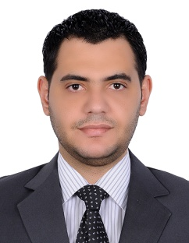
Mohamed
Mohamed.364388@2freemail.com

Education
Bachelor of Arts
University of Mansoura –Egypt 2002-2004
Work experience

01/11/2016 to presently
- Security manager at (Coral Dubai Deira Hotel)

24/05/2015 to 25/10/2016
- Security shift leader at (Crwone plaza Dubai Deira hotel) IHG

26/12/2006 to 26/05/2012
- Security officer & CCTV operator at (Shangri-La hotel Abu Dhabi)

(Reference available upon request)
Trainings and certificates
(Dubai police academy) 2017

- Security manager professionals training course and certificate (DPS & SIRA)
- DPS Portal online usage training and certificate

Abu Dhabi police (National Security Institute) 2009

- Security officer training and certificate

Intercontinental Hotels Group (IHG) 2015

- Crisis management

- General fire training

- Fire life safety training

- Security awareness

Job Description
- Recruiting , Training and supervising security officers, CCTV operators & guards

- Controlling budgets for security operations and monitor expenses

- Attend meetings with other managers to determine operational

- Plan and coordinate security operations

- Investigate and resolve issues

- Obtaining brand safety and security standard

- Coordinate with police regarding security requirements

- Risk assessment

- Develop and implement security policies and procedures

- Coordinate staff when responding to emergencies and alarms

- Create reports for management on security statues

- Review reports on incidents and breaches

- Set up security plans and firefighting plans for the hotel

- Develop evacuation plans of all crisis types

- Solve guest issues professionally
Skills

- Highly dedicated to work under any turbulent situations
- Leadership and creativity
- Planning organizing and punctual
- Ability to learn so quickly
- Diplomatic
- Self confidence
- Cooperation with team work

- Eight years of Experience in security and hospitality industries
- Time management and patience
- Fidelity and seriousness at work
Languages

- Arabic: Native
- English: Fluent
IT skills

- Microsoft Office (word-Excel-power point)
- Internet browsing (mail-outlook)
- Opera PMS system
- English & Arabic typing
- E-Learning
Personal Details
- Nationality : Egyptian

- Religion :Muslim

- Place of birth :Iraq

- Date of birth :02-06-1982

- Marital status :Married
Career Objective

-Seeking a challenge position in a progressive organization
That offers opportunities for advancement, development
Effectively to improve my skills

-To work in a position gives me the chance to apply my
Experience

