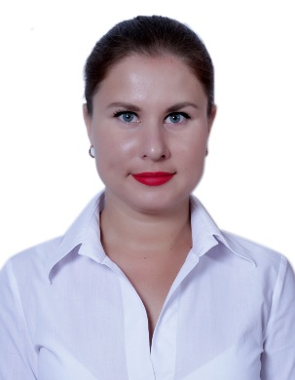
Personal information

Name |  | Dariia  Dariia.364408@2freemail.com

Work experience
• Dates |  | March 2016 – present time
• Name and address of employer |  | Intercontinental Hotel Abu Dhabi
• Type of business or sector |  | Food & Beverage
• Occupation or position held |  | Waitress/Hostess
• Main activities and responsibilities |  | Greeting guests and seating them to their tables; presenting menus and answering questions about the cuisine, making recommendations upon request; recommending drinks to guests; taking orders from guests and serving food, drinks and deserts;bar service; taking action to correct any issues, as needed; preparing bill/receipts and collecting payment from customers; cleaning tables and other areas as needed.

• Dates |  | June 2015 – September 2015
• Name and address of employer |  | Ottoman, Cafe & Restaurant, Istanbul, Turkey
• Type of business or sector |  | Food & Beverage
• Occupation or position held |  | Greeter /Hostess
• Main activities and responsibilities |  | Greeting and seating guests; giving quick and exact information and directions to guests; answering all questions regarding the menu and services; ensuring coverage of the hostess stand at all times; answering phones, taking messages and making reservations.

• Dates |  | December 2012 – February 2016
• Name and address of employer |  | Gorn Company, Ltd., Kharkiv, Ukraine
• Type of business or sector |  | Industry/Sales
• Occupation or position held |  | Secretary
• Main activities and responsibilities |  | Preparing general correspondences, reports, schedules, purchase orders and other materials from rough draft, copy, marginal notes or verbal instructions; answering correspondence as directed by supervisor; maintaining appointment calendar, scheduling appointments, conferences, and meetings; checking and reviewing a variety of data for accuracy and conformity to established standards and procedures; collecting and preparing data for records and reports making arithmetical calculations.

• Dates |  | Fabruary 2012 – November 2012
• Name and address of employer |  | Terrace, Cafe & Restaurant, Kharkiv, Ukraine
• Type of business or sector |  | Food & Beverage
• Occupation or position held |  | Waitress
• Main activities and responsibilities |  | Providing a warm welcome for guests; receive food & drink orders and serve guest requests to the standards required; serving dishes to guests at tables; ensure timely delivery of all food & beverage items to guests; understand menu content and keeping up to date with any menu changes; making recommendations from the menu if requested; answer guest queries in a polite and helpful manner; clearing cutlery and dishes away from tables; passing food orders through to the kitchen staff promptly; ensuring the food service area is left clean and tidy once all the guests have left

Education

• Dates (from – to) |  | September 2007-May 2012
• Name and type of organization providing education and training |  | Kharkiv National Automobile and Highway University
• Principal subjects/occupational  skills covered |  | Transportation Management; Customs Control for Motor Transport
• Title of qualification awarded |  | Specialist of Transportation Technologies
• Level in national classification  (if appropriate) |  | Specialist (Master)

Mother tongue |  | Ukrainian, Russian

Other languages |  | English- fluent; German, Turkish- basic

Social skills and competences |  | Good organizational skills, determination, self-motivated, rapid adaptation to the new position, stress resistance, leadership, sense of organization, friendly.
Technical skills |  | MS Office, Internet, Micros
Hobbies |  | Traveling, sport, music, reading, socializing and cooking

