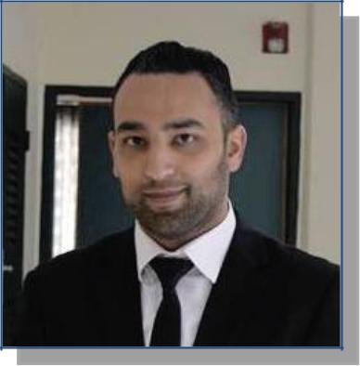
Momen
Momen.364413@2freemail.com

Sex : Male | Date of Birth : 29/06/1993 |

Nationality : Jordanian

Languages : Arabic (Native) English (Good)

Visa Status: Visit Visa

EDUCATION

August 2011 – December 2015

September 2010 – July 2011

WORK EXPERIENCE

Bachelor of Building Engineering

An-Najah National University, Nablus, Palestine

Graduation Project

Integrative Design Of a Masjed .
Architectural ,Structural & Mechanical Design

Tawjihi Secondary Education Certificate

King Talal Secondary School, Nablus , Palestine with 93.2 GPA

- Arab Engineering Services and Consultations
Site Engineer Jan. 2016 – Nov.2016

Main Responsibilities:

- Work on structural design for several projects residential, commercial.

- Make Structural shop drawings.

- Site engineer.

- Supervision for excavation reinforcement and concrete works for foundations, columns, beams, and slabs.

- quantity survey

Projects

- united cars showroom (Supervision)

- Bravo Mall (Supervision)

- Residential Building (Design & Supervision)

Page 1 / 2

TRAINING

PERSONAL SKILLS

IT SKILLS & PROFICIENCY

- Reach Call Center

  - Call Center Agent 144 “ Paltel “ ( Dec 2014 - Dec 2015 ), during study in university.

  - Call Center Agent 111 “ Jawwal “ ( Jun 2016 – Dec 2016),an evening Work.

  - Directing calls and responding to customers

- Member at Jordan Engineers Association
May 2016

- Accept my registration as a member of the Association in the

Division : Civil ENG

Section of : Building Structure ENG

- Trainee at Arab Engineering Services and Consultations Office
June 2015- Aug 2015

  - Residential, villa projects.

- Seismic Design of Buildings Engineers Association license N/233
May 2015

- Reach Call Center
Directing calls and responding to customers in communication Companies

- Trainee at EWB organization (Engineers Without Borders )
Sep 2012 - Nov 2015

Work on several engineering projects which improve my technical skills and teamwork.

- Building design
- Structural inspections
- Technical report writing
- Extreme load assessment
- Structural steelworks

- AutoCAD programme

- SAP software programme

- E-TAP programme

- Revit programme

- ICDL, Financial Excel.

- Competent with most Microsoft Office programs(word, power point, excel)

- skills of HTML

Page 2 / 2

