CURRICULUM VITTAE

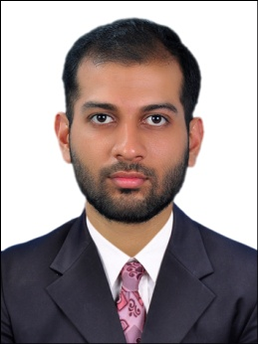
APPLICATION FOR THE POST OF IMAGING TECHNOLOGIST

JITHU
JITHU.364424@2freemail.com

Current location : On visit –ABUDHABI ( 26th april - 20th july 2016)
HAAD PASSED ON : 19 /9/2016

WORK EXPERIENCE

- Worked as Medical Imaging Technologist (MRI Technologist) in the Department of Radiology at BABY HOSPITAL (NABH ACCREDITED,800 bedded) , Calicut , Kerala (India) from 8/12/2014 to 27/3/2017
- Worked as Medical Imaging Technologist in the Radiology Department of COLOMBIA ASIA HOSPITAL (NABH ACCREDITED) ,Bangalore, Karnataka(India) from 22/4/2014 TO 4/12/2014

ACADEMIC QUALIFICATION

- LICENSE:
HAAD EXAM : PASSED ON 19 /9/2016

- Bachelor of Science in Medical Imaging Technology (B.Sc. MIT) , from Father Muller Medical College, Mangalore, Karnataka under Rajiv Gandhi University , Bangalore , graduated in the year 2013.

- 12th Standard – Kerala Higher Secondary Examination 2009
- 10th Standard – Secondary School Leaving Certificate 2007 KERALA

AREAS OF EXPERIENCE

MAGNETIC RESONANCE IMAGING
Prepare and screen the patient
Patient positioning and Handling coils
Imaging Techniques of Head, Spine, Extremities, Musculoskeletal,
Perform Angiograms
Special Procedures
Quality control Test and Management
Recognition of Image Artifacts and Rectification
Image documentation & safety precautions

Worked with:
GE SIGNA HDXT 1.5T 16 CHANNEL
GE Advantage Workstation ADW 4.5 and 4.7

COMPUTED TOMOGRAPHY
Prepare and position the patient
Performs all types of Scans (Head, Thorax, Abdomen, Spine and Extremities)
Performs Dynamic Angiograms (Renal, Carotid, Cerebral, Pulmonary, Peripheral)
Performs all kind of 3D Works at Advantage Windows
Recognition of Image Artifacts & Rectification
Image documentation

Worked with:
GE REVOLUTION 128 slice MDCT
GE LIGHT SPEED 64 slice MDCT
TOSHIBA AQUILION 64 slice MDCT
GE BRIGHT SPEED 16 slice MDCT

RADIOGRAPHIC TECHNIQUE
Performs all Plain X-Rays and special procedures

Worked with:
Digital Radiography (DR) SIEMENS
Computerized Radiography (CR) FUJI
SIEMENS Kilinoskop 800MA ( Fluoroscopy with spot camera)
SIEMENS 600 MA, 500 MA
GE ELPRO 300MA

DECLARATION

I hereby declare that all the above furnished details are true to the best of my knowledge.

