SYEDA
Syed.364439@2freemail.com
~ Process Supervisor ~
Derivatives Documentation and Marketwire Back loading

Built distinguished, 5+ years record of progressive achievement across Investment Banking(Corporate Banking); currently working with Deutsche Bank, Bangalore as a Team Lead for Client facing team .

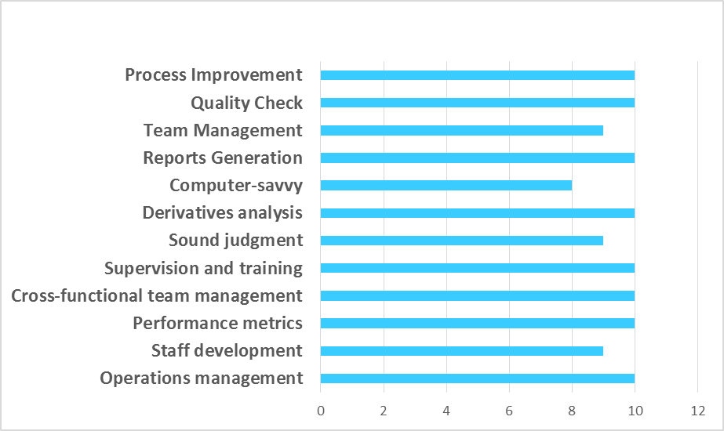

Highly accomplished professional with broad range of skills for evaluating financial data investment trends and the best ways to strategize asset selection. Knowledgeable in practices principles terminology and calculation resources for analyzing derivatives. Adroit in monitoring of interest rates and currency hedges and the best ways to utilize them. Comfortable ensuring employees comply with risk control protocols in financial transactions working directly with proprietary traders corporate portfolio managers and risk managers. High-energy Supervisor successful in building and motivating dynamic teams of 8 EFT s and responsible for their training & performance. Managed my team member’s daily responsibilities and productivity. Familiarity with standard tools of mathematical finance. Possess in-depth knowledge of Marketwire and DTCC chasing. Good exposure to trade clearance , Reconciliation ,Settlement of cash flows ,sales support, Corporate action ,VAT and applications such as DTCC &Marketwire. Cultivates a company culture in which staff members feel comfortable voicing questions and concerns as well as contributing new ideas that drive company growth. Result and customer service driven with emphasis on detail accuracy and excellence. Organized and diligent with excellent written& oral and interpersonal communication skills.
PROFILE SUMMARY
CORE COMPETENCIES

2011 Bachelor of Business Management in Finance from Maharanis Arts & Commerce college Mysore Karnataka
ACADEMIC

CAREER GRAPH

KEY ACCOUNTABILITIES
Primary Responsibilities/Essential Functions:
- Supervision of confirmations for the income derivatives desks.
- Ensure team is accurately producing/reviewing/executing confirmations and settling cash flows in a timely manner.
- Ensure teams are resolving discrepancies in a timely manner, and escalating issues as appropriate.
- Provide daily/weekly/monthly reporting files as necessary.
- Confirming and executing trades as per CFTC & EMIR regulation.
- Capturing details from incoming document received from counterparties, validated details in outgoing confirmations to ensure trade confirmations reflects correct parameters.
- Reviewing current procedure and identify the areas of improvement and make necessary changes.
- Doing quality check and provide an approval for trade execution.
- Working with sales desk of different regions helped me to understand different aspects of the market and made me versatile to work in any environment.
- Chasing and resolving different discrepancies in the trades considering standard set forth by ISDA.
- Effectively manage operational risks, clearing and compression functions and participate in process improvement initiatives and system development.
- Booking the trades as per the trader supervision & update the same to the Back office about the new trades flown.
- Work closely with the trader/ Front office to ensure all the trades are booked as per the term sheet & standards.
- Amend the bookings if there is any incorrect bookings due to system bug, or human error.
- Track Inventory & maintain accounts to identify any discrepancy.
- Update accounts with accurate information.
- Reconciled discrepancies efficiently and in a timely manner of customers.
- Resolved account reconciliation issues quickly to avoid financial loss.
- Update client frequently during any discrepancy regarding reconciliation.

Decision-Making Responsibility:
- Responsible for the timely escalation of critical risk issues to Management.
- Responsible for the reasonable determination of applicable course of action for resolving discrepancies.
- Performs according to prescribed procedures.
- Keep close eye on DK trades or any open risk item and getting it resolved as soon possible to avoid financial loss.
- Determining and confirming derivative trade regulations and terms handling operational process.
Team Management:
- Working in sync with 4 different teams and make sure trade is getting executed correctly in given time line.
- Provide feedback to team members if there is any incorrect execution of trade.
- Updating team on their performance by publishing various reports on weekly & monthly basis.
- Each team member must:
  - Be aware of the Operational Risk scenario associated with the role and acts in a manner that takes account of operational risk considerations.
  - Ensure compliance with Operational Risk controls in accordance with regulatory standards and policies; and optimize relations with regulators by addressing any issues.
  - Promote an environment that supports diversity and reflects the brand.
  - Have good exposure & experience in client interaction .

Highlights:
- Appreciated for handling two platinum clients at a time although, being in training period.
- Won employee of the month & spot awards for excellent performance.
- Has always been one of the top performer at work.
- Received appreciation from Client & from Management team.

Name: Syeda
Date of Birth: 30th April 1991
Sex: Female
Marital Status: Married
Date of expiry: 26 Dec 2026
Nationality : Indian
Languages Known: Urdu, Hindi, English and Kannada
Hobbies : Reading , Listing to music.

PERSONAL DOSSIER

Please scroll down for project d

PROJECTS HANDLED

Clients Deutsche Bank(Process related internal)
Platform Electronic Platform
Tools Used DTCC (Depository Trust clearing Corporation) Migration
Responsibilities Lead the project for 3 months. Main responsibilities is to bring down the manual work & also reduce the FFT's so that we can reduce the cost.
Description Project was initiated to migrate the electronic platform to reduce the head counts, where DTCC was handled by the different person after migration one head count should handle both the platform which is paper & electronic.
Location Bangalore
Duration 3 Months
Team Size 7

Clients Process related (Deutsche Bank)
Platform UAT
Tools Used Confidential hence not disclosing the applications name.( Mainly on UAT testing for application set up for the process. We can also call it as application Migration.
Responsibilities Was part of UAT testing where we have to test the cases daily & give the feed back to Business Analyst team for improvement or any changes in the application
Description Change of Application for 6 teams hence it was a very critical project where we were eliminating the manual work to increase the production & with the help of the Business engineering teams.
Location Bangalore
Duration 1.3 years
Team Size 12

Clients JPM, GS, UBS, RBS,Bank of America, Citi Bank, Barclays, BNP and Morgan Stanley.
Platform DTCC
Tools Used DTCC windup for rates assets class
Responsibilities Was leading the project across for the global teams to close out the outstanding trades which are yet to confirm & also to post the exit from DTCC for all live trades & backload exited trades on another platform (paper or marketwire). & Preparing the reports on daily basis & publish the same to senior management keeping a close eye on the O/S items & chased the concerned team or Manager to prioritize the issue .And also chased client to confirm the exit from their end.
Description DTCC was closing out hence had to post exit on all the live trades & backload the same in to other platform.
Location Bangalore/Jaipur
Duration 2 Months
Team Size 16

Clients RBS & ABN Amro
Platform Migration
Tools Used Migration of Client Entity (RBS & ABN Amro)
Responsibilities Responsible for clearing the 1600 trades alone for ABN Amro within 35 days deadline. Contacting the internal teams for smooth & correct execution of trades & also provides daily updates to client & senior management on the discrepancies /or issue on the trades & also provides the Number of executed trades daily.
Description RBS & ABN Amro had executed the trades in German Language which later RBS & ABN had change their entity due to migration internally for which they had asked Deutsche Bank to rebook the trades in English with correct legal name & entity .The project is called Erasmus Migration.
Location Bangalore/ Frankfurt
Duration 3 months
Team Size 2

