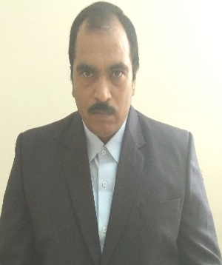
R E S U M E

KAVIRAT
KAVIRAT.364466@2freemail.com
________________________________________________________
SKILLS:
- Accounting, Auditing and Finance Experience of 25 years (Above 15 years as Head of Accounts).

- Can do all types of Accounts from preparation to finalization and Taxation works.

- Accounting Packages (Tally.ERP9 and MS Excel nearly 19years Experience).

- Liaisoning and Submission of periodical returns with Sales Tax, Income Tax, Labour Department, PT, P.F etc, Handled Income Tax Scrutiny and sales Tax Appeals.

- Statutory Deduction of Taxes like TDS, WCT etc. from Sub-contractor / Vendor Bills and timely remitting with the department concerned and issuing necessary certificates.
- Maintenance of Stores Inventory under computerized System (Tally) matching with Account Books.
- Involved in Physical inspection of Stock (Assets, Consumables & etc.) of the organization lying at site.
EMPLOYEMENT ABROAD:
- Worked as Head of Accounts in Hotel Sapphire Group, Dar Es Saalam, Tanzania from Jan’14 to Sep’16( Verification of All Accounts, Payroll, Submission of Statutory returns of Vat,NSSF,Paye etc ,Finalization work)
EMPLOYEMENT IN INDIA:

- Worked in M/s. K.N.R. Constructions Ltd a company involved in Civil Construction work in India and abroad also. Worked as Accounts Manager in N.H.A.I ,road project of cost 580crores related to NH-7 at Nirmal, Adilabad Dist. from Jan’2008 to Feb’2011 and worked at N.H.A.I Road project (NH-69) of cost Rs.330Crores in the state of Madhya Pradesh up to Dec’2013.

- Worked as Accounts Manager in PallaviSudha Projects Ltd, Guntur. Activities of the company is real estate business and construction of residential and commercial apartments and complexes for 2 years. Works preformed are all activities relating to finance and accounts.

- Worked as Sr.Accounts Officer in Santi Arts Hi-Tech Medias Ltd, Guntur a worldwide famous in advertising media and having clients in all over India for 8 years. Works performed are preparation and finalization of Accounts, preparation of sales tax returns. Attended for Income tax scrutiny cases and sales tax appeals under Works Contract Act.

- Worked as Accounts Officer at Kallam Agro Products & Oils Ltd, Guntur for 3years. Prepared the accounts of Solvent & Refinery plants Construction.

- Worked as Audit Assistant after completion of articles of C.A for 7years.Attended for bank audits conducted Tax Audits and done several Internal audits & Statutory Audits.

EDUCATION QUALIFICATION:
- Bachelor Degree in Science from Acharya Nagarjuna University, Guntur in 1986 & Completed C.A Articles in J.S Ramakrishna &Co, Guntur on 1989

