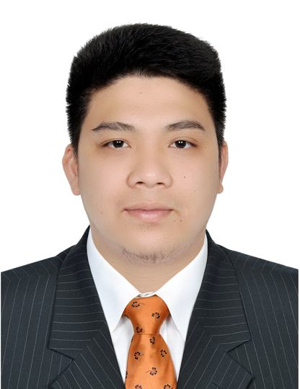
RAMON

RAMON.364495@2freemail.com

POSITION DESIRED: Any position that suits my work experiences. (Open for Interview)

OBJECTIVE:

To acquire the available position where my knowledge, skills and capabilities can mostly be utilized and advanced to contribute to the achievement of your company’s goals and visions.

PROFESSIONAL STRENGTHS:

- Possesses excellent verbal and written communication skills
- Knowledge of basic operating systems like Microsoft Word, Excel, PowerPoint and the internet
- Ability to supervise, monitor a team, to maintain and build good relationship with clients
- Ability to work under pressure and in high paced working environment
- Relate well with people from a variety of cultures

WORK EXPERIENCE:

LG Jumbo Electronics – Doha Qatar Sales Representative
Sept. 2014 to Jan 2016

Responsibilities:

- Helping and communicate from the customers in what they need
- Prepare the items for the customers.
- Stay focused on the item to that we sell.
- Stay informed of store policies, procedures.
- Responsible for ensuring store appearance is clean and presentable at all times.

SuperL Philippines, Inc. - Pampanga, Philippines Line Leader of Hardware/Embossing
November 2012 to March 2014

Responsibilities:

- To conduct inspection and test per control plan, work instruction and procedures.
- Train Line Workers on the procedure to assemble products per assigned role for the day/week.
- Ensure all employees abide by the safety regulations
- Perform quality checks of the line
- Perform other duties as needed or assigned

IQor Philippines – CSEZ Pampanga, Philippines Customer Service Representative
October 2011 to March 2012

Responsibilities:

- Obtains client information by answering telephone calls, interviewing clients and verifying information.
- Determines eligibility by comparing client information to requirements.
- Obtains client information by answering telephone calls, interviewing clients, verifying information.
- Establishes policies by entering client information and confirming pricing.
- Informs clients by explaining procedures, answering questions and providing information.
- Maintains communication equipment by reporting problems

Sutherland Global Services Clark Economic Zone Customer Service Representative
Pampanga, Philippines June 2011 to Sept. 2011

Responsibilities:

- Responsible for inbound call
- Responsible in answering all guest inquiries and questions
- Collect accurate information from customers essential in purchasing online
- Secure customers private information specially bank accounts
- Process ordering of products and making sure that product will be received by customer in the most convenient way they could
- Process online payment

Jcamilo’s Catering Events and Services

Responsibilities:

- research venues, suppliers and contractors, and then negotiate prices and hire.
- oversee the dismantling and removal of the event and clear the venue efficiently.
- manage a team of staff, giving full briefings.
- produce detailed proposals for events (for example, timelines, venues, suppliers, legal obligations, staffing and budgets.

EDUCATION:

Holy Angel University Bachelor of Science Major in Civil Engineering
Angeles City Philippines S/Y: 2010 – 2012

I hereby certify that all of the above mentioned information is true and correct to the best of my ability and knowledge.

