MUHAMMAD  MUHAMMAD.364594@2freemail.com | 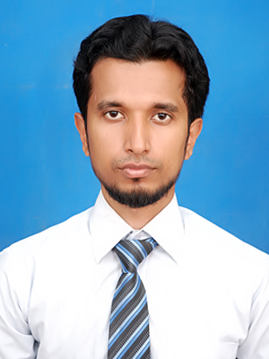

Career Objective

A diligent and proficient Accounts Executive having Accounts management skills and capacity for achieving targets, keenly looking for leading position where I can utilize my previous experience in benefiting future growth & success of the organization

Professional Experience

Suzuki South (dealership Of PAK SUZUKI MOTOR CO LTD) Nov 2012 till present
Senior Accounts Executive

Job Responsibility
- Bank Reconciliation Statement
- Vender Reconciliation Statement.
- Checking Reports Account Activity report, cash/bank consolidation Report, Parts sale reports, Purchase report and job sale report on dialy basis
- Client & Vender Interaction & making follow-up for Payments.
- Making Cheques for parties.
- Maintain Ledger for Sales, purchase.
- Cash Handling & Preparation of Day Book. Petty cash processing.
- Prepare corporate & individual sales tax return.
- Prepare WHT tax details.
- Checking daily sales report, stock in report & stock out report on daily basis.
- Coordinate with internal auditor.
- Debit/ credit note.
- Stock valuation.
- Monthly payroll processing.
- Fixed assets records.
- Annual budget preparation.
- Managing monthly aging of receivables for monitoring of cash flows.

Paramount Company July 2009 to Sept 2012

Accountant

Job Responsibility

- Prepare and maintain scorecard data and develop strategy to enhance the motivation at work.
- Inventory management.
- Provide training to new and existing staff as needed.
- Handle personnel issues relating to staff conflicts, absenteeism, performance issues, etc.
- To check that all processes and procedures are completed, quality standards are met, and that projects are profitable,Solving queries of clients.
- To generate receivables and payables management reports
- To check payroll records and payments.
- To prepare all the documents relating financing
- Maintaining office records, customer/supplier database.
- Bank Reconciliation, Customer and Supplier Reconciliation.
- Monitoring the funds position and vendor payments to ensure payments are released as per credit terms and policy.

ACCA
Passed one fundamental paper

Masters in Business Administration (Finance) 2011
Mohammad Ali Jinnah University
Karachi, Pakistan

Bachelors in Commerce 2007
University of Karachi
Karachi, Pakistan

Intermediate (Pre-Engineering) 2005
Aisha Bawany College
Karachi, Pakistan

Matriculation 2002
Happy Home High School

Certification

- Islamic Banking & Takaful from Center for Islamic Economics

Technical Skills

Software
- Microsoft Office 2007, Word, Excel, PowerPoint
- Peach Tree,tally
- ERP software

Personal Profile

Date of Birth : 21st August, 1985
Religion : Islam
Nationality : Pakistani
Marital Status : Single

