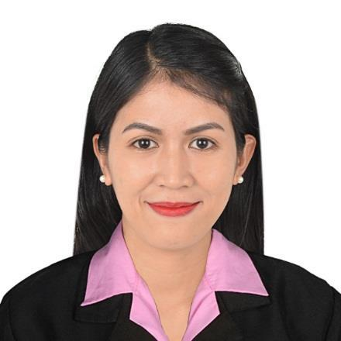

MARIA
MARIA.364601@2freemail.com

❖ SUMMARY OF QUALIFICATION

To pursue a highly rewarding career, seeking for a job in challenging and healthy work environment where I can utilize my skills and knowledge efficiently for organizational chart.

Highlights
  - Managing diaries and making appointments

  - Booking rooms and travel arrangements
  - Drafting letters and other documents, such as PowerPoint presentations
  - Maintaining filing systems
  - Answering the phone and answering queries
  - Photocopying and printing
  - Using various computer packages – Word, Excel, PowerPoint

- PROFESSIONAL EXPERIENCE

HOSPITAL CASHIER CUM SECRETARY
Saint John The Baptist Medical Center Inc.

January 2014 to January 2017

Calamba City, Laguna, Philippines

- Handle payments for services rendered to patients by receiving and recording them properly

- Process transactions for hospital admissions and services and receipts

- Accurately entering daily payment activities into hospital database

- Create daily cash report
- Maintain petty cash logs, receipts and balance daily basis

- Interacting with the customers that come to the counter
- Assisted in filling out admission and insurance forms and ensured that all acquired data is correct

- Provided visitors with direction to patients room, wards and treatment rooms
- Handled telephone exchange by providing information and transferring calls
- Greeted patients, families and visitors and provided them with the information regarding the facility

- Thorough understanding of making copies of printed documents, and filing correspondences, reports and records

➢ Computer: Extremely proficient in Microsoft Office applications

RECEPTIONIST
Grand Villa Resort and Butterfly Centre

November 2009- March 2013

Bay, Laguna, Philippines

  - Serve visitors by greeting, welcoming, directing and announcing them appropriately

  - Answer, screen and forward any incoming phone calls while providing basic information when needed

  - Receive and sort daily mail/deliveries/couriers
  - Maintain security by following procedures and controlling access (monitor logbook, issue visitor badges)

  - Perform other clerical receptionist duties such as filing, photocopying, collating, faxing etc.

- SEMINARS ATTENDED

- APPRENTICESHIP STANDARD

Seminar conducted by: Technical Education and Skills Development Authority Calamba City, Laguna

❖ EDUCATION AND QUALIFICATION

College / Tertiary Bachelor of Science in Tourism

2005-2009 Laguna State Polytechnic University (Los Baños Campus)

❖ PERSONAL INFORMATION

Age: 29
Birth Date: July 08, 1987

Civil Status: Married
Citizenship: Filipino

Religion: Roman Catholic

Visa Status: Visit Visa

I hereby certified that the above mentioned particulars are true to the best of my knowledge and belief.

