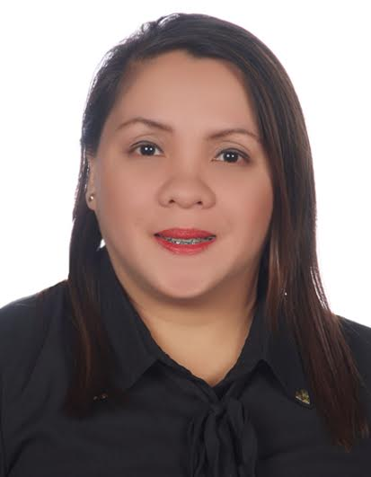
JONAH
JONAH.364603@2freemail.com

Objective

Seeking position as Junior Accountant/ Bookkeeper/ Accounting Executive /Treasury Executive /Cashier with a reputed company such as yours. To be part of your company in promoting quality and excellent service that would give customer satisfaction. I would like to work for the best of the company’s goal and objective. And Self Worth. To be competent among others, highly motivated and respected by others in the field of work and in life.
Profile Summary:

- A dynamic Professional with a commitment to Excellence, with almost 9 years of experience in UAE Insurance Industry and more than 10 years in Philippine Banking industry,
- With Multi tasking ability, proven to manage multiple tasks both in Technical, Cash & Accounting & Admin matters at level best
- With high level of integrity and high consciousness to Accountability
- Team Spirit and can work with diverse group(s) of people
Areas of Expertise:

- Accounting .Cashiering.Treasury Skills
- Banking Skills ( Branch Banking Operation)
- Communication/Interpersonal Skills
- Computer Skills
Employment History:

- Accounting Executive, National General Insurance Sharjah , UAE – ( April 2014 – till present)

- Accounting Assistant.Cashier, National General Insurance Sharjah , UAE – ( August 2008 – March ,2014)

- Junior Branch Operations Officer , Peninsula Bank, Davao City, Philippines (February- 2008, June,2008)

JOB DESCRIPTION

- Job as Accounting Executive Accounting Assistant .Cashier, (National General Insurance Sharjah , UAE August 2008 – Till Present)
- . Responsible for issuing receipts on all the payments/collections made for cash, checks & credit card payments for Life, Motor, General & Medical Insurances premium received at daily rest.
- Responsible for balancing Day end cash and cheques collections
- Over all Cash Custodian./Responsible for handling cash, checks, keys of the safe & its content and in charge for the Deposit of the branch collection(s) daily , records & updates Post Date Cheques for payments daily.
- Responsible for handling branch funds, petty cash, commission funds, marketing funds and its disbursements & replenishments
- Submits branch daily Cash & Accounting reports to HO on daily basis/ cash & cheques collections /cashiers daily balance & reports .
- Recording all incoming/outgoing claim cheques and the release of the cheques
- Managing accounts payable and accounts receivables
- Generates Statement of Accounts for various brokers and branch Sales Executives
- Post commission accordingly paymemts received from the brokers/agents/clients
- Allocation of payments of received from various brokers
- Generates Monthly Sizing of Account and moniotors long overdues of BDE’s
- Handles Administrative matters
- Job Profile as Junior Bank Operations Officer , Peninsula Bank, Davao City, Philippines (February- 2008, June,2008)

- Responsible for the Branch Accounting Operations. Act as Clearing Officer ; maintenance of branch book of accounts and balancing day-end transactions ( front & back office transactions), Conducts Cash Count and Spot Audit on Cash matters,
- Prepares and analyze accurate Central Bank Reports, Financial Statements, Bank Reconciliation Statement, Branch Performance Report and all other reports required by the management. Knowledgeable in General Accounting such as General Ledger Posting, Bookkeeping, Account Analysis, Journal Entries and Reconciliation, Cost and Expense Control.
- Handled Inward & Outward Foreign & Local Remittance(s)
- Handled Clearing of cheques, Customer Service and Teller Post
Educational Qualification:

College Holy Cross of Davao College, Davao City
Bachelor of Science in Commerce Major in Marketing - October 1995
Achievements/Affiliations: - Deans Lister /Honor’s List
- School Publication Staff Writer
- Grant – In – Aid Scholar

Trainings & Certificates: Available at Hand

REFERENCES: Available Upon Request.

I hereby certify that all information(a) herein are true and correct.

