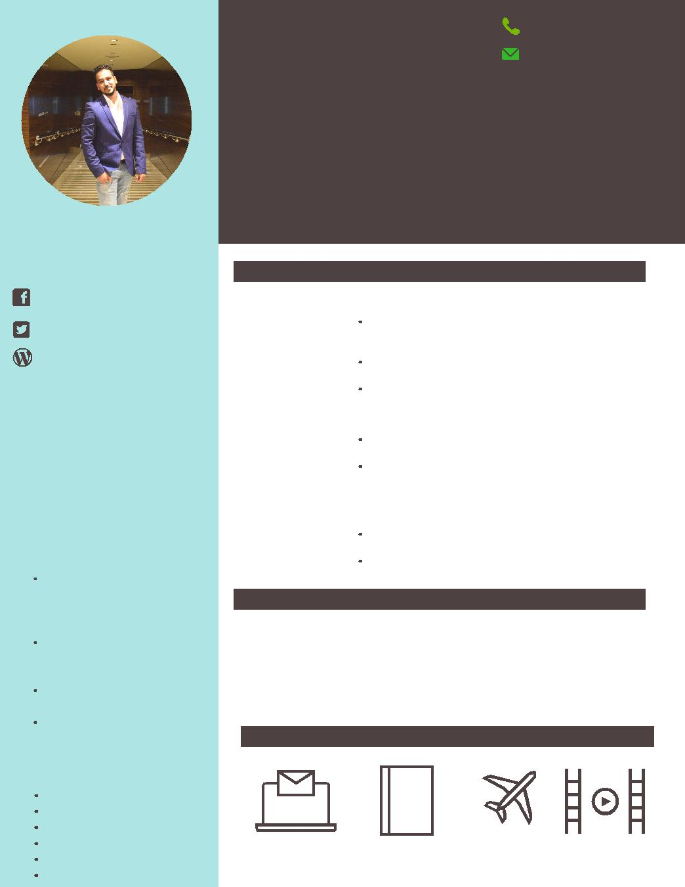
ABDUL.364609@2freemail.com

P R O F I L E

Friendly and flexible Travel Consultant with excellent customer service skills and a successful track record of assisting clients in finding travel package deals and providing them with competitive yet profitable trips.

ACCOMPLISHMENT

Attended a training batch of 60 days in Make My Trip Pvt. Ltd. For Holiday packages.

Well versed in all CRS system (Amadeus, Galileo, Sabre).

Good geographical

knowledge.

Excellent written and verbal communication.

S K I L L S

Self-motivated

Highly competitive

Sales analysis

Customer service

Interpersonal skills

Client development

A B D U L

T R A V E L C O N S U L T A N T

P R O F I L E

2 01 5 - 2 01 7 Musafir.com | Holiday Consultant

Research various destinations and means of travel regarding prices, customs, weather conditions, reviews etc.

Use promotional techniques and prepare promotional materials to sell itinerary tour packages. Reach the revenue and profit targets

2 01 4 - 2 01 5 All4Seasons Travel | Travel Consultant

Handling inbound call for international and domestic airfare inquiries.
Achieving monthly target in terms of the tickets issued and revenue generated.

2 01 3 - 2 01 4 Motif India (Goibibo.com) | Sales Executive

Handling international airfare queries from sales staff and corporate clients.
Maintain professional image by responding all

inquiries in stipulated time

EDUCATION

2 01 3 - 2 01 3 | IATA - Foundation level
 | Sai Seven Sea Institute
2 01 0 - 2 01 3 | Bachelor in Business Administration
 | Sardar Patel University

H O B B I E S

Internet |  |  |  |  |  |  |  | Travel |  |  |  |  |  | Travelling | Movies
 |  |  |  |  |  |  | Blogging

