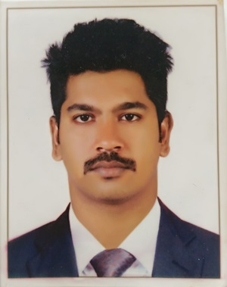
PRINCE
PRINCE.364626@2freemail.com

PROFESSIONAL QUALIFICATION:

- BE in MECHANICAL ENGINEERING.

- DIPLOMA in MEP DESIGNING AND DRAUGHTING.

PROFESSIONAL OBJECTIVE:

- More than 1 years of work experience in MEP Designing and Supervising.
- Gained knowledge and experience in HVAC and Plumbin & Fire Fighting system.
- Highly adaptable in quickly changing technical environments with good teamwork skill.

WORK EXPERIENCE:
Company : S.S Engineers and Consultant, Kerala, India.
Designation : Site Supervisor
Duration : 6 months
Nature of Work : Site supervising and Draughting using AutoCAD.
Responsibilities:
To Prepare the design and drawings on AutoCAD & attending site meetings.
To check the work as according to approved drawing.

WORK EXPERIENCE:
Company : Aghora Infrastructure Private Limited, Kerala,India
Designation : MEP Design Engineer Trainee
Duration : 6 months
Nature of Work : Heat & Load calculation and duct designing using AutoCAD , Plumbing Design
and Fire Fighting.
Responsibilities:
Prepare the design and drawings on AutoCAD, Making client meeting in site

WORK EXPERIENCE:
Company : Sterling and Wilson Private Limited, Hyderabad,India
Designation : Plumbing Engineer Trainee
Duration : 4 months
Nature of work : Plumbing drawings using Autocad,
Responsibilities:
coordination with the team members, to check piping line according to given drawing & measurements.

ACADEMIC DETAILS:

DEGREE | UNIVERSITY/COLLEGE/SCHOOL | YEAR OF PASSING | PERCENTAGE
BE (Mechanical) | Vels University, Chennai, Tamil Nadu | 2014 | 62.76
AISSCE | Government Model Senior Secondary School, Port Blair, Andaman Nicobar Islands (CBSE) | 2009 | 67.6
AISSE | Carmel senior secondary school, Port Blair, Andaman Nicobar Islands (CBSE) | 2007 | 64.0

FINAL YEAR PROJECT:

- FEA Analysis and Experimental Investigation of Coating on aluminum Piston Material by Plasma Spray Technique.

ACHIEVEMENTS:

- Event Organizer in school, college and church functions, other technical events.
- Active participant in cultural activities & have won many prizes.
- Participated in Indian Coast Guard Open School Drawing and Painting competition.
- Participated in India Post stamp design and written philately quiz.
- Participated in All India Radio program.

TECHNICAL SKILLS:

PG Diploma in MEP Designing and Draughting.

- Heat and Load calculation using HAP in HVAC.
- Design in Duct Designing in HVAC.
- Selection and installation of transformer and generator.
- Selection of cables, Selection of bus-bar and protection devices.
- Design of electrical panel boards, electrical physical layout.
- Preparation of schematic drawings (SLD) using AutoCAD.
- Designing in Plumbing, selection of pipe size and Fire Fighting System and MEP Revit.

Platforms: Windows 10/8/7/XP/Vista.

Other skills: AUTOCAD-2015 and 2013 , HAP, BETA performance data, Duct and Pipe sizer, MEP Revit.

KEY SKILL
- Good learner & listener, punctual and believe in team work.
- Well developed, motivational and leadership qualities.
- Adaptable and supportive.

DECLARATION:

I hereby declare that all the particular stated here are true to the best of my knowledge and belief.

