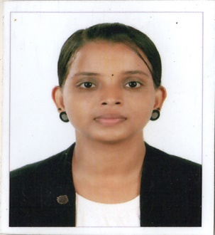
SHELMA
SHELMA.364654@2freemail.com

PROFILE
Solution-oriented and versatile nursing professional with valuable skilled nursing experience that includes interdisciplinary care team contribution, plan of care development detailed assessment and patient advocacy, combine strong administration and nursing management skills with accountability for positive patient outcome. Highly developed organizational skills, accustomed to maintaining high productivity level with heavy workload companionate patient advocate who demonstrate caring professionalism when working with patients their families versed in the critically of maintaining confidentiality with regards to patient care and status.
CERTIFICATIONS:
- Registered nurse and midwives is dated 06-04-2015
- Registered nurse and midwives is dated 1st October 2016
- BLS certifications , Tech2people Kannur – 2017

PROFESSIONAL EXPERIENCE:
- Registered nurse
- Kannur medical college and hospital, Kannur – staff nurse 2014-2015
- Koyili hospital, Kannur – staff nurse 2015-2017
DUTIES:
- Observing and recording the condition of patient.
- Monitoring a patient condition by taking temperature, pulse, respiration.
- Arranging patient admission and discharges.
- Taking the hand over from a previous staff.
- Making sure all equipment is sterilized before procedure and treatment.
- Identifying ways to grow and develop the nursing service.
- Checking and administrating drugs and injections.
- Providing accurate highly records.
- Responding quickly to emergencies.
- Maintaining good relationship with patients.

KEY SKILLS AND COMPETENCE:
- Team leadership skills and able to supervise junior staff.
- Familiar with computerized patient information.
- Having the drive and determination required to deliver the highest possible standard of care to patient.
- Experience of working with client with complete need and care co-ordination.
- Keeping increases of charge in nursing and also understand current challenge in the profession.
EDUCATION QUALIFICATION:
Course | Year | Institution
Bachelor of science in nursing | 2014 | Dhanalakshmi Srinivasan College Of Nursing, Perambalur, Tamilnadu
Higher Secondary | 2010 | Kadambur Higher Secondary School
SSLC | 2008 | Kadambur Higher Secondary School

INTERESTS:
- Kalaripayattu
- Dancing
- Drawing
- Travelling
PERSONAL INFORMATION:
Date of Birth & age: 26/12/1992
Nationality: Indian
Gender: Female
Marital status: Single
Languages known: English, Hindi, Malayalam, Tamil

