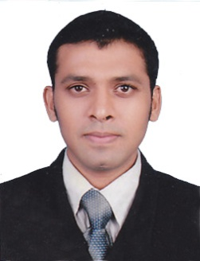
Resume

Shakir

Shakir.364656@2freemail.com

OBJECTIVE

I am an enterprising young professional intending to continue my development as a consultant. I think in terms of results and objectives, I am enthusiastic, and I work with decisiveness and conviction. I have a proactive attitude and find positive ways to stimulate and engage with people.

Educational Qualification

- Bachelor of Commerce, DRBCCH College Chennai (2005-2008)
(Madras University)

COMPUTER LITERACY

- Knowledge of Accounting package Tally ERP9
- Knowledge inM.S Office, Excel

Work Experience (UAE)

Organization : Topmost General Trading company L.L.C.

Nature of Work : Manual & Computerized Accounting

Position : Sales Executive

Period : Mar 2017

Work Experience (India)

Organization : Axis Bank Private Ltd (chennai)

Nature of Work : Retail broking

Position : Sales

Period : June 2014 to Dec 2016.

Organization : Zeenath Silks &SareesPvtLtd.Kottakkal, Kerala

Nature of Work : Manual & Computerized Accounting

Position : Accountant

Period : May 2009 to Jan 2014

Work Experience (UAE)

Organization : SkyfabPvt Ltd.

Location : Sharjah - UAE.

Nature of Work : Manual & Computerized Accounting

Position : Accoutant and PRO ( Public Relations Officer)

Period : From July 2008 to April 2009

PERSONAL DETAILS

Date of Birth : 03 - 07 - 1985
Sex : Male.
Nationality : Indian
Marital Status : Married
Declaration

I here by declare that all the information is true and best of my knowledge.

Date:

