MUMTAZ
MUMTAZ.364661@2freemail.com

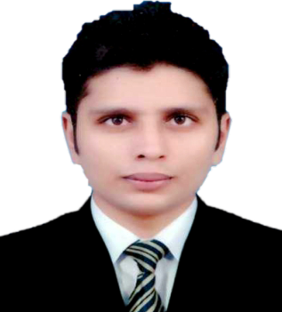
Fashion shows, Exploring fashion philosophies
Gaming, Photography, Painting, etc.
EDUCATION
BBA (Hons) - Finance
University of Central Punjab, Lahore - Pakistan
VISA STATUS
Visit Visa (valid Until June)
OBJECTIVE
WORK EXPERIENCE
ASSITANT ACCOUNTANT
Cotton Heights
- Completing ﬁnancial reports on a regular basis and providing information to the ﬁnance team
- Entering ﬁnancial information into appropriate software
programs
- Managing company ledgers
- Preparing ﬁnancial documents such as invoices, bills, and accounts payable and receivable
- Coordinating internal and external audits
- Verifying balances in account books and rectifying discrepancies
From 2013 to 2017
To make positive contribution as part of your dynamic and well reputed organization in a position where my management, decision making
and communication skills will be appreciated
Preparing ﬁnancial documents such
as invoices, bills, and accounts payable and receivable
Completing purchase orders
Managing payroll
INTERNSHIP
Sajjad Textile Mills Limited
From 2012 to 2013
Completing ﬁnancial reports on a regular
basis and providing information to the ﬁnance team
Assisting with budgets
Completing bank reconciliations
Managing company ledgers
HOBBIES & INTERESTS
Verifying balances in account books
and rectifying discrepancies

