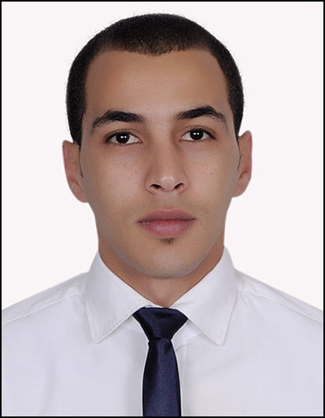ABDELHAK
ABDELHAK.364673@2freemail.com
DUBAI – UAE

Objective: I have more than 6 years professional experience in different industries, 1 year as an administrator with Import Export company, 4 years as Public relation officer with Cargo company
I’m seeking a challenging position as PRO, HR executive with ability to get position in Human resources department in a reputable organization that matches my ambitious and motivated personality to utilize my practical experience and qualifications.

Work Experience:
Current job: Retail sales representative, Toys r us - Al futtaim Company L.L.C
Al-Futtaim Group employs over 44,000 people and operates eight divisions comprising automotive, electronics, insurance, services, real estate, retail, industries, and overseas
Duties and responsibilities :
- Promote the sales of products by spotting and seizing sales opportunities, offering alternatives solutions to problems and suggesting add on sales in order to achieve the established sales target.
- -suggest means of sale improvement to the supervisor as well as determining slow moving or non-selling items and suggesting sales action.
- Maintain a fully display of products via merchandising methods as laid down by the company. Remain aware of developments in the local market by being attentive, to information given by customers, to advertising and promotions in the media and also by making scheduled market visits so as to be able to maintain the company's competitive advantage and to properly advise customers.
- Keep an update on changes in the company's products range such as new items or changes in existing items as well as informing the Sales Manager of any customer's problems/comments on the product range or gaps in the range.
- Conduct a daily detailed inspection of his assigned area so as to review the availability and positioning of price labels, product information tags and other communication media.
- Review daily stock level on all products in his assigned area and recommends orders to the Shopkeeper.
- Coordinates with Procurement Executive for information pertaining to stocks in his assigned area.

2012 – 2016: Public relation officer - Palms trading co. Limited - Guangzhou city. Guangdong province. China
Palms trading co. Limited part of Golden commercial groups , a logistic company in China that operates all north Africa in Algeria, Morocco and Tunisia , also with new branches in Japan and south Korea created in 2014
Duties and Responsibilities :
Liaise and coordinate all the governmental requirements pertaining to the employees and office such as renewal of licenses, permits, visas, labour contracts, gate passes, medical insurance and dealing with police administration if required
- follow up and update management regarding new governmental legal requirements and processes
- Assist in clearing governmental payments, ensures completeness and accuracy of data
- compile and maintain office and employee and management retention records and information security policy
- commit to deadlines and ensure timelines of renewals
- create, edited and maintain electronic and written communication in both Arabic or English
- Assist in coordinating and planning the execution of executive visits, conference and special events relates to permits and passes
-Perform transportation duties on needed basis such as picking up and dropping staffs from office to client place and vice versa
- act as back up to other team members as needed
-manage time sheet and attendance

Educational Background

2013—2016: Bachelor Degree.
Laarbi ben mhidi university – Algeria
Work psychology and Human resources management
2011 – 2013: Certificate in business organization
Institute of Economy and management – university of setif – Algeria
2009 – 2011: High school graduated. Mentouri high school – Algeria
Economy and commercial sciences
Language skills
Arabic - native Speaking. Writing. Reading
English - advanced Speaking. Writing. Reading
French –advanced Speaking. Writing. Reading

