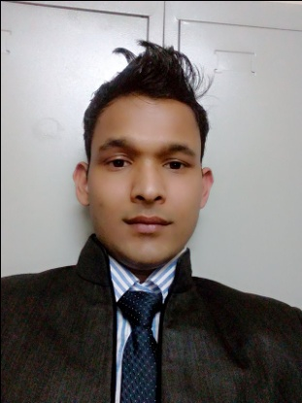
Curriculum vitae General Information
Name: Chandra
Chandra.364686@2freemail.com
Education
Board | Instution | Division | Passed(yr)
Diploma in Pharmacy | Bhageshor Academy for Health Science(CTEVT) | First(1st) | 2013
S.L.C | Shree Asigram Secondary School | Second(2nd) | 2008
Experince
- Worked as Pharmacy Assistant at Padma Hospital Private Limited.
- Worked as store incharge in azad pharma distrubator.
- Worked as meadical representative at kathmandu location in Yashokayani pharmaceutical company.
- Now still working in pizza hut as cashier and servier from last 18 month.
Skill
- Diploma in Computer Software from Unique Computer institute.
Training
- One week rotational training at Department of hospital and Clinical Pharmacy in Manipal Teaching Hospital, Pokhara
- Participated in 2 days Implementing Life Skills training from PVP Nepal.
- Participated in 3days Leadership & Carrier Development Training from NCI Dhangadhi Kailali.

