Rahul
Rahul.364699@2freemail.com 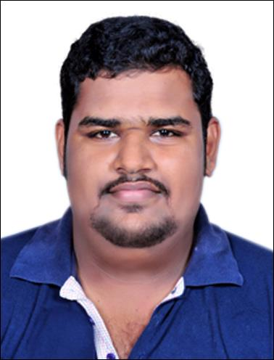

Objective

To use and apply skills gained through my educational background and experienced to obtain a challenging and competitive position, with a quality organization, leading to increasing responsibilities and career advancement.

Summary of Work Experience:

Working as an Assistant Accountant cum Stores In-charge with M/s. Medinova Medical Supplies L.L.C Mussaffah, Abu-Dhabi, since September 2012.

Job Responsibilities:
- Preparation of Invoices, Receivables & Payables Statements and follow-up of receivables.
- Preparation of various statements to cut/avoid loss of revenue.
- Preparation of supplier’s payments.
- Preparation of Bank Reconciliations Statements.
- Maintaining Petty Cash of the Organization.
- Processing and finalizing the monthly transaction checking of monthly payroll to ensure accuracy.
- Preparations of Monthly Financial Reports.
- Handling various assignments relating to Finance Department.
- Store Management including maintaining stock records, conduct physical verification of stock on regular basis, update the management about reorder status etc.
- Very wide and excellent contacts in UAE.
- Tender quotations, follow up & sourcing.
- Exceptional listener and communicator who effectively conveys information verbally and in writing.
- Flexible team player who thrives in environments requiring ability to effectively prioritize and juggle multiple concurrent assignments.
- Results-driven achiever with exemplary planning and organizational skills along with a high degree of detail orientation.
- Resourceful team player who excels building trusting relationships with customers and colleagues.
- Productive worker with solid work ethic who exerts optimal effort in successfully completing tasks.
- Dependable, responsible contributor with commitment to excellence and success. Highly motivated self-starter who takes initiative with minimal supervision.

Store in Charge

- To make the Item coding procedures.
- Prepare the aged item stock report
- Maintain the minimum stock level
- Supervise the packaging and handling of materials.
- Make stock ledger report as per Management requirement,
- Stock confirmation for each inventory documents,
- Annual closing.
- Create the stock valuation report.
- Generating all required reports regarding dispatch of products using MS-Excel.

Educational Qualification

- Completed Bcom with Computer Application at Amrita Vishwa Vidyapeetham, Kollam, India.
- Completed +2 (Kerala) (2006-2008) with a percentage of 65% in Commerce from Marthoma Higher Secondary School, Venmoney, Alapuzha, India.

- Completed 10th (Kerala) (2005-2006) with percentage of 70% from JMHSchool, Kodukulnnji, Alapuzha, India.

OTHER SKILLS AND COMPETENCIES:

- Good Communication Skills in both Written and Spoken English.
- Good computing skills in Microsoft Office, Tally ERP, Trade Easy. PACT, Microsoft Outlook& Photoshop.
- People management and team building.
- Presentation skills.
- Event Co-odinator for College Day, Sports Day etc.
- Learning about new ideas and creative skills for self-development
- I do have good relationship with the reputed medical Consumables Suppliers in UAE
ACHIEVEMENTS:

- Researched and submitted a paper presentation on a comparative study on the three
Banking sector innovative products of different insurance scheme during the 3rd semester.
- Researched and analyzed the Pharmaceutical Sector as a paper presentation for the BSDP (Business Skills Development Program) conducted in my college by MSME (Micro, Small and Medium Enterprises), Government of India, during the 3rd and 4th semester.

Project Details

- A research report on identifying the job satisfaction level of the employees in The Kerala state coir corporation Ltd Alappuzha dist.

Industrial Visits

- Kerala Minerals and Metals Kollam Kerala India
- Apollo Tires Private LTD Kerala India.
- Modern bread factory Edappally Ernakulam Kerala
- The Kerala state coir corporation Ltd Alappuzha, Kerala

Key Skills

- Good Motivational and Communication Skills
- Ambitious, Enthusiastic, Creative and Dedicated to work
- Leadership Qualities and Smart work Nature

Languages Known

- English ( WRS )
- Hindi ( WRS )
- Malayalam ( WRS )
- Tamil (S)

Personal Details

- Nationality : Indian
- State : Kerala
- Sex : Male
- Marital status : Single
- Date of Birth : 08-11-1990
- Driving License : Driving License UAE (Manual)
- Visa Status : Holding Residence Visa of UAE (can be cancelled/transferred within minimum time)
- References : Can be furnished upon request.

Declaration

I hereby declare that above information speechified is true is true to the best of knowledge and belief. I consider myself familiar with Accounting. I shall be highly grateful if you could provide me with an opportunity to do work in your esteemed organization. I look forward for favorable response.

