**PROFESSIONAL SUMMARY**

**JENNIFER**

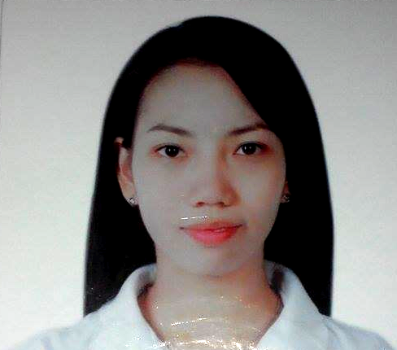

**OBJECTIVE:**

To be able to apply all my knowledge and skills in a working environment that would help me to develop myself as a professional and as a person.

**WORK EXPERIENCE:**

**Administrative Assistant cum Secretary**

Al Nafees Building Materials & Seapal Contracting Est.

March 15, 2014 to Present

Abu Dhabi, United Arab Emirates

**Work Responsibilities**

* Provides administrative/secretarial support for the department such as answering telephones, assisting visitors and the likes.
* Maintain office supplies for the office.
* Promotes good relationship with the clients and site personnel.
* Coordinate to sales staff, Store Keeper, Accounts Department and Executive Manager, General Manager and Deputy General Manager with regards the orders, delivery, Invoices, payment (LC or Transfer) and shipments of materials.
* Prepare and modify documents including correspondence, reports, drafts, memos, and emails.
* Manage all the documents and materials that are coming in and out of the office.
* Maintain electronic and hard copy filing system
* Sort, distribute and follow-up incoming mail and faxes.
* Makes sure that controlled copies of latest approved document and drawing are given to the appropriate staff, subcontractors and suppliers as applicable for all projects.
* Checking and reviewing documents including Petty Cash, Inquiry, Quotation, Purchase Order, Invoice and Delivery Note.
* Keep track of quality, quantity, stock levels, delivery or schedule of shipment, transport costs, documentation and efficiency.
* Contact carrier representative to make arrangements and to issue shipping instructions and delivery of materials.
* Complete documentation such as packing lists, bills of lading, work orders and shipping orders using computer-based technology

[**JENNIFER.364705@2freemail.com**](mailto:JENNIFER.364705@2freemail.com)

**POSITION DESIRE:**

**Any vacant position may suit my knowledge & experience.**

**SPECIAL SKILLS:**

* Proficient in oral and written English
* Skillful in Microsoft applications such as MS Word, Power Point and MS Excel.
* Can type of up to 40 words per minute.
* Knowledgeable in business documentation.
* Able to work with minimal supervision.
* Capable to deal with different individuals.
* Hardworking, trustworthy, fast learner, flexible and responsible.
* Can read and write stenography/shorthand

**PERSONAL ATTRIBUTES:**

* be honest and trustworthy
* be respectful
* possess cultural awareness and sensitivity
* be flexible demonstrate sound work ethics

Page 1

* Liaise and negotiate with suppliers, manufacturers and clients.
* Coordinating drivers, vehicles, loads and journeys.
* Monitoring cargo movement through the tracking system
* Schedule and coordinate meetings, appointments and travel arrangements for Managers
* Responsible for all employees’ records.

**DATA CODER**

Toshiba Information Equipments (Phils.), INC.

September 2008 – January 2009

Laguna Philippines

**Work Responsibilities**

* Provide general administrative and clerical support including mailing, scanning, faxing and copying to management
* Maintain electronic and hard copy filing system
* Open, sort and distribute incoming correspondence
* Records all the documents and materials that are coming in and out of the office.
* Perform data entry and scan documents
* Assist in resolving any administrative problems
* Run company’s errands to post office and office supply store
* Answer calls from customers regarding their inquiries
* Prepare and modify documents including correspondence, reports, drafts, memos and emails

**OFFICE ASSISTANT**

Fujitsu Computer Products Corporation of the Philippines

December 2007 –June 2008

Laguna, Philippines

**Work Responsibilities**

* Provide general administrative and clerical support including mailing, scanning, faxing and copying to management
* Maintain electronic and hard copy filing system
* Open, sort and distribute incoming correspondence
* Records all the documents and materials that are coming in and out of the office.
* Perform data entry and scan documents
* Assist in resolving any administrative problems
* Answer calls from customers regarding their inquiries
* Prepare and modify documents including correspondence, reports, drafts, memos and emails

**PERSONAL DATA:**

Date of Birth : July 29, 1988

Place of Birth : Pila, Laguna, Philippines

Marital Status : Single

Nationality : Filipino

Languages : English and Filipino

Gender : Female

Visa Status : Employment Visa

**EDUCATIONAL BACKGROUND**

**Tertiary**

* **BS Office Administration**

Laguna State Polytechnic University

Laguna, Philippines

2009 – 2013

* **Diploma in Computer Secretarial**

Laguna State Polytechnic University

Laguna, Philippines

2009 – 2011

* **Two Years Office Management**

Laguna State Polytechnic University

Sta. Cruz, Laguna

2005 – 2007

**Secondary**

Masico National High School

Pila, Laguna

2001 – 2005

**Primary**

Pila Elementary School

Pila, Laguna

1994 - 2001

Page 2

**ON THE JOB TRAINING**

**Account Assistant**

National Irrigation Administration, Philippines

November 2010 – March 2011

November 2012 – March 2013

**Assistant Clerk**

Municipality of Pila, Philippines

November 2006 – March 2007

**Office Practicum Training**

Laguna State Polytechnic University

Santa Cruz, Laguna

June 2006 – October 2006

Page 3