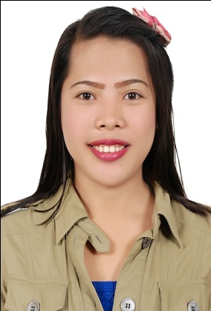

GRACE
GRACE.364761@2freemail.com

Applying for secretary/HR /Admin
CAREER OBJECTION:

- I would like to have a career that will widen my knowledge and skills to improve myself and sense of well-being.

SUMMARY OF QUALIFICATIONS:

- Meticulousness in keeping records and making reports.
- Honest, patient and trustworthy
- Can work under pressure with less supervision and has strong determination to achieve goals.
- Computer literate and has a knowledge of MS Office Application such as MS Word, MS excel and MS PowerPoint and Outlook.

WORK EXPERIENCE

Secretary, Admin Assistant/ HR assistant
House of Beech for Wooden & Décor Industry LLC
Industrial 11, Sharjah, UAE
February 2015- Present

Duties and responsibilities:

- Answering telephones, inquiries and in coming emails, relay telephone messages and fax messages and also for assisting visitors.
- Responsible for making scheduled and coordinate meetings, interviews, appointments, events and other similar activities for supervisors, which also include travel and lodging arrangements to Managing Director.
- Prepares daily, weekly and monthly reports assigned by the Director.
- Responsible for making quotation and provide documents support to the project teams.
- Responsible for updating the employees report such as visas expiration date and ID’s and the cancellation as well.
- Responsible for making Job Orders to the production.
- Entering the employee’s document in the system.
- Responsible to contact the PRO to make renewal the documents of the company and the laborers as well.
- Responsible to follow up the pending inquires/ quotation to the Managing Director.
- File and retrieve corporate documents, records, and reports such as company Licenses and etc…Monitoring with my database the company documents expiration such as Trade License, Rent contracts, Employees renewal, Insurances and etc.

Clerk cum Receptionist
EDUHOME ENTERPRISE INCORPORATED, Philippines
September 2009 – November 2013

Duties and responsibilities:
- Performed administrative duties of maintaining reports and providing support information.
- Worked in office computers- printed reports, documents, and typed as needed.
- Assisted various departments in sorting out queries by providing them with accurate, correct information.
- Prepared payroll report for the staff.
- Performed accounting work such as bank transactions, accounts reports and insurance.

CERTIFECATE

RIZAL COMMERCIAL BANKING CORPORATION (RCBC BANK)
OJT
January 2014 – May 2014
Nabunturan, Compostela valley Province

Duties and responsibilities:
- Sorting all folders of the holders to the volt
- Update all the documents of the holders
- Perform other related tasks assigned by the Manager

SEMINARS/ TRAININGS

2012 DOLE/SEMINAR
OCTOBER 9, 2012

QUALITY CONSCIUOSNESS AND LEADERSHIP TRAINING CUM TEAM BUILDING
ROTARACT AT ASSUMTION COLLEGE OF NABTURAN

EDUCATIONAL ATTAINMENT

2010-2014 Tertiary Level BACHELOR OF SCIENCE IN BUSINESS ADMINISTRATION
Major in Financial Management
Assumption College of Nabunturan
Nabunturan, Compostela Valley Province

PERSONAL DATA

Gender : Female
Civil Status : Single
Nationality : Filipino
Date of Birth : June 23, 1991
Language : English and Tagalog
Visa Status : Employment Visa

I hereby certify that all information obtained above is within my knowledge and belief.

