- 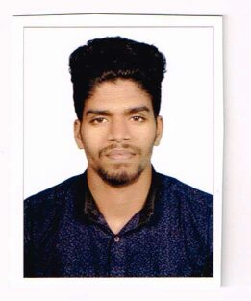 MUHAMED
- MUHAMED.364783@2freemail.com

- To seek a challenging position in a multinational organization .which will provide me with the opportunity to contribute creatively and positively towards the organizational objectives.

- Personal details :

  - Date of Birth : 10/05/1996
  - Marital Status : Single
  - Citizenship : Indian
  - Religion : Islam
  - Visa status : Visit Visa (Till valid – July 8th 2017)

- Education / qualification:

- Course | - Name of institution/ Board
- Diploma in Logistics & Shipping | - Kerala Govt. India
- Plus Two ( Higher Secondary School ) | - Kerala Govt. India
- S.S.L.C ( High School) | - Kerala Govt. India

- Personal Strengths:

- Strong determination to succeed
- Quick learner and hardworking
- Work independently and as part of a team
- Flexible and adapt quickly to new working environments

- Driving License:

- Indian Valid license.

- Language Known:

- Fluently in- English, Hindi , Malayalam.

- Declaration:

- I do hereby declare that the above furnished details are true to the best of my knowledge and belief.

