CIRCULUM VITAE
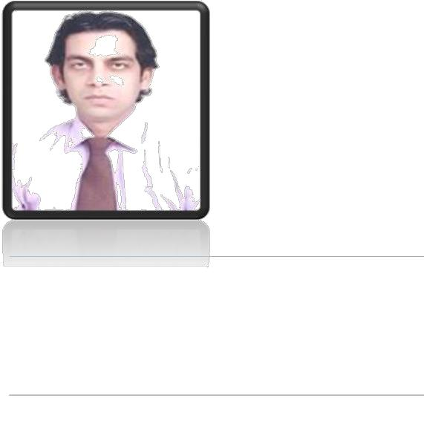

AMIR
Amir.364805@2freemail.com

FATHER’NAME: | : | HAFEEZ ALI
DATE OF BIRTH | : | 01ST MAY 1975
MARITAL STATUS | : | MARRIED
DOMICILE | : | KARACHI(SIND)

I NEED A POSITION WHERE I CAN PROVE MY EXPERTISE, EXPERIENCE 19⁺ YEARS AND COLLECT REASONABLE RESPECT AND FINANCIAL BENEFITS. SPECIALLY COMPUTER / DATA ENTRY OPERATOR. I AM CONFIDENT WITH MY WORK. I SELECT MILD STONE TO ACHIEVE ANY GOAL AND THIS MY WORKING WAY. I AM READY TO WORK IN YOUR ORGANIZATION.

SKILL & EXPERTIES

- ELECTRIC & MANUAL TYPING

- ACCOUNTS

- COMPUTER LITRACY

- STATISTIC WEB DEVELOPMENT

- MS.OFFICE

- ADOBE PHOTO SHOP

- INPAGE

- INTERNET

- DATA CONTROLLER

QUALIFICATION
- MATRIC SCIENCE

- CERTIFICATE IN COMMERCE

- DIPLOMA IN COMMERCE

TECHNICAL QUALIFICATION

- COMPUTER MODULE-I

- ELECTRIC & MANUAL TYPING

- ENGLISH LANGUAGE MODULE-1

WORK EXPERIENCE

A. ADVANCE RADIOLOGY CLINIC (PVT, LTD) SINCE 1997 TO 2007 (APRIL)
Largest diagnostic center in Pakistan around 500 patients diagnose in a day.
- WORK IN 1997 TO 2000

  - AS A COMPUTER OPERATOR

- WORK IN 2000 TO 2006 NOVEMBER

  - AS A MEDICAL TRANSCRIPTOR

- WORK IN 2006 NOVEMBER TO 2007 MAY

  - AS A ACCOUNT ASSISTANT

B. ABBASI SHAHEED HOSPITAL (KMC) 2007 MAY TO 2010 FEB
Government organization.

- WORK IN MAY 2007 TO JANUARY 2008

  - AS A DATA ENTRY OPERATOR

- WORK IN JANUARY 2008 TO DECEMBER 2008

  - AS A INCHARGE DATA ENTRY OPERATOR

- WORK IN JANUARY 2009 TO FEBRUARY 2010

  - AS A SUPERVISOR RADIOLOGY DEPARTMET

C. CARDIAC EMERGENCY CENTER
Government organization.

- LANDHI (KMC)KIHD-IV FEBRUARY 2010

  - TILL TO DATE

- WORK IN FEBRUARY 2010 TO 15 AUGUST 2010

  - AS A COMPUTER OPERATOR

- WORK IN AUGUST 2010 TO MARCH 2012

  - AS A ASSISTANT (CME) CLINICLE MEDICAL EDUCATION DEPARTMENT

- WORK IN MARCH 2012 TILL TO DATE

  - GENERAL SUPERVISOR (GS) HOSPITAL

- BASIC COMPUTER KNOWLEDGE (WELFARE INSTITUTE)

SINCE 2012 TO MAY 2013
  - I AM KNOWLDEGE PROVIDES TO DATA COLLECTION AND SOME OTHER

STUDIES OF BASIC COMPUTER STUDEIES.

- DAR UL SEHAT HOSPITAL

    - AS FRONT OFFICER JUNE 2013-DEC 2014

- IMAM ZAIN UL ABIDEN HOSPITAL PHARMACY

- POS (POINT OF SALE) SYSTEM OPERATOR AS CASHIER

