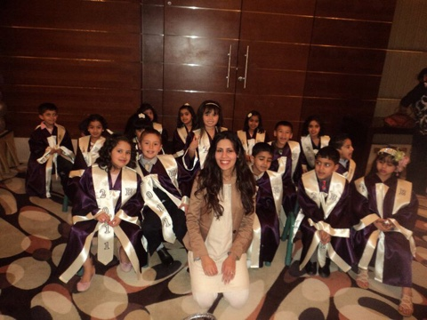

Marina
Marina.364811@2freemail.com

EXPERIENCE

Al Hayat Universal Bilingual School
KG1 Teacher, Pre-K Teacher 2014- present

Responsibilities: planning and delivering well-structured lessons and field trips, management of resources, organization and support of extra-curricular activities, adherence and implementation of health and safety policies, effective application and planning of the North American curriculum, teaching of numbers, letters, motor skills, knowledge and understanding of the world and community, conversational skills.

British Playhouse, Mangaf, Kuwait
KG 1 Teacher, Pre-K Teacher, Head of Department 2010- 2014

Responsibilities: application of the jolly phonics curriculum, teach students blending of letters and motor skills, formulation of reports and assessments, maintained health and safety standards, organization of graduation, systematic curriculum review, planning of classes for department, management of 6 staff and 75 students.

Play and Learn Nursery, Derby, United Kingdom
Nursery Nurse 2004-2006

Responsibilities: attained first aid qualification, completed early years childhood courses, mentor to ten children, maintained health and safety standards of the nursery, weekly child development assessments, compilation of academic reports.

Happy Child Nursery, London, United Kingdom
Nursery Assistant 2003-2004

Responsibilities: mentor to eight students, taught motor skills, monitoring of early development, undertook risk assessment of the nursery.

EDUCATION

GCSES Featherstone High School, London. August 2000
GNVQ Business Studies Heston Sixth Form 2000 - 2001
GNVQ IT Uxbridge College, London 2001 - 2004
Mark Making Workshop Derby 2006
Child Development Derby 2007
Nursery Health and Safety Training Derby 2008
First Aider in the Workplace London 2006
English Language and Education Teaching Hertfordshire 2006 - 2009

MISCELLANEOUS

References available upon request.

