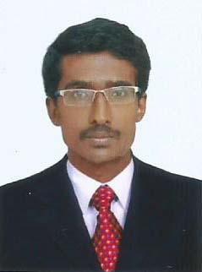

ADITIONAL BENIFIT ; NATIONAL HOSPITALITY SKILL CERTFICATE .APPROVED BY GOVT. OF INDIA.
Albin
Albin.364821@2freemail.com

Objective:

. A challenging position in a reputed organization, where I can effectively contribute as well as develop my knowledge and skills in providing services, through persistent hard work and above all with due regard for professional ethics.

Summary of Skills and Qualifications:

- Hard working
- Organizing skill
- Confidence with effective communication skill

IT Exposure & Skills

- C++ Programming
- Windows, MS Office, Online Operations
- Attended food prodution course conducted by the ministry of tourisam govt of india.HUNAR SE ROZGAR .KITTS

Working Experiences:
- cashier in a caffeteria ( 2 YEAR)

- Field Exicutive.(Delivery executive)
Instakart service pvt ltd.(delivery for online products).(FLIPKART)
Pala. Kerala. imdia ( 1 YEAR)

Extra curricular Activities &Achievements

- NCC
- Participate inter colligate union budget analysis competition
- Participate inter colligate photography competition
- Co-Ordinator of ECO-FIESTA 2014 held at St,Thomas college pala

Educational qualification
- Bachelor Degree in Economics with Banking, St.Thomas college pala, M.G.University (2011 – 2014)
- Plus two with 62% in Computer Science from OLL HSS Uzhavoor(2009-2011)
- S.S.L.C. with 78% from St. josephes H.S.S. kudakkachira (2008 – 2009)

Personal Details

Date of Birth : 10th February 1993

Marital Status : Single

Visa Status : Visit Visa – Date of Expire: 4 june

Nationality : Indian

Languages Known: English, Hindi and Malayalam

