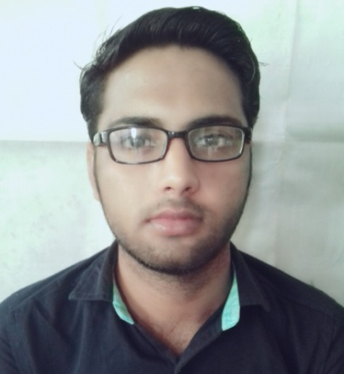
CURRICULUM- VITAE

DANISH

DANISH.364833@2freemail.com

CAREER OBJECTIVE
Desire to work for an organization with well defined core VALUES ,bringing in passion, team spirit and desire to obtain results, leading to personal and professional development.

EDUCATIONAL QUALIFICATION
COURSE : DEGREE (B.COM WITH ACCOUNTS)
PERIOD : 2014 - 2017
BOARD/ UNIVERSITY : SAMBALPUR UNIVERSITY
SPECIALIZING : COMMERCE

COURSE : PLUS TWO
PERIOD : 2012 - 2014
BOARD/ UNIVERSITY : central board of secondary education (CBSE)
SPECIALIZING : COMMERCE

PERSONAL STRENGTH & ABILITIES
- Ability to multitask and manage conflicting demands.
- Ability to cope and work under pressure.
- Good written and verbal communication skills.
- Positive attitude & initiative

ACHIEVEMENTS

- Have participate in many cultural events in my college days.
- Have taken initiatives and organized many program in gnps school.
- Have won many awards for drama and elocution at school college level.
LEISURE INTEREST

- SURFING INTERNET
- PLAYING CRICKET
Personal objective:

To better my ability to take ownership , increase manaegement skills and develop into an entrepreneur.

IT SKILLS
- KNOWLEDGE IN MS-OFFICE
- EXCEL (V-LOOKUP, HLOOKUP,PIVOT TABLE)
- POWER POINT
- OUTLOOK
- INTERNET BROWSING
- TALLY ERP 9
Personal information

Date of birth : 23th may ,1996
Nationality : Indian
Religion : islam
Sex : male
Language status : English, hindi, oriya, and some knowledge
Of Arabic
Physical status : height: 5’8 and weight: 64 kg

Declaration

I do hereby declare that the particulars of information and facts stated herein above are true correct and complete to the best of my knowledge and belief.

