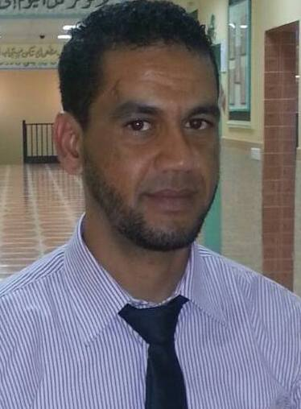
Curriculum vitae
Lassad
Lassad.364857@2freemail.com
- Objective
- To obtain a position in progressive manner where I can use my variety of skills to increase productivity and to contribute to the overall success of the company.
- Profile: Results-oriented Customer Service and Administration Associate with over 06 years’ experience. Proven leadership skills that help team members achieve individual goals, enhance customer service, and drive business goals. Looking to take next career step in Customer Service and leadership with a respected dealership dedicated to delivering high quality service and building relationships with customers.
- Core Qualifications
- Professional and personable in all customer and coworker relations
- Ability to listen attentively to customers
- Exceptional communication skills and ability to use positive language
- Extremely organized in all aspects of work with multi-tasking ability
- Leadership, coaching and mentoring and Ability to motivate and train others
- Excellent problem-solving skills
- Education
- Bachelor degree in experimental sciences in 2003 – Tunis
- Master degree in English language in 2008 – Tunis
- Diploma in computer science in 2009
- Professional Experience:

- 2014 (Present): Team Leader at Directlines Tunis
- Oversaw daily activities and supervised a team of Customer Service Representatives who provided technical support to company’s customers
- Solving all major customer problems/queries that subordinates were not able to solve earlier
- Trained and supervised customer service professionals to ensure optimum satisfaction of clients
- Managed a team of Client Services Associates that focused on meeting Customer Service efficiency and quality standards
- Led the process of hiring customer service representatives.
- 2011-2014: Customer Service Representative at Teleperformance

- Deal directly with customers either by telephone or emails
- Respond promptly to customer inquiries
- Handle and resolve customer complaints
- Obtain and evaluate all relevant information to handle product and service inquiries
- Provide pricing and delivery information
- Perform customer verifications
- Set up new customer accounts
- Process orders, forms, applications and requests
- Record details of actions taken
- Provide feedback on the efficiency of the customer service process.

- Training and certifications
- Certificate for outstanding performance \ Tunis
- Time management training
- Customer mindset training
- Evolving supervisor
- Basic guide for selling training
- Problem resolution training
- Education:
- Master degree in English language and civilization: June 2008
- Bachelor degree in science: June 2003
- Languages:
English: fluent
Arabic: fluent
French: fluent
- Interests: sports, music and reading
- skills: computer, customer service, problem solving
- Character: so active and cheerful

References are available upon request

