OBJECTIVES:  To widen my knowledge and develop my skills that would enhance my technical ability and proficiency that could further improves my eligibility as an employee.  HIGHLIGHTS OF QUALIFICATION:  Highly organized dedicated and committed to professionalism. Work well under pressure with attention to details. Train and develop certain individuals to achieve full potentials that eventually lead them to be an asset and leader of the company.  EDUCATIONAL BACKROUND:  AB CULTURAL LANGUAGEs  Major in JAPANOLOGY  2005 – 2006  Under Graduate  Secondary Level:  Carlos P. Garcia High School  Graduate: 2005  Primary Level:  Celedonio Salvador Elementary School  Graduate: 2000  Civil Status: Married  Nationality: Filipino  Height: 5’5  Religion: Catholic  Age: 30  Birthday: January 03,1987  Status: visit visa | Rachelle  Rachelle.364897@2freemail.com | 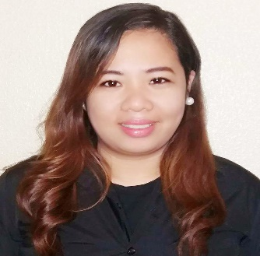
SKILLS
● Committed to customer service and confident in interactions to individuals at all level.
● Persistent and self- motivated with excellent communication abilities.
● Goal-Oriented team player with consistent focus on achieving superior
productivity.
● Dedicated and hardworking individual with strong sense responsibility
toward a given task
● Quick learner and trained in analytical and problem solving in achieving work
goals.
● Resourceful in completing under pressure jobs and can work independently
with a minimum supervision.
● Proficient in Microsoft Application (Word, Excel and power point and
Internet).
WORKING EXPERIENCES:

DELFI SHIPPING AGENCY INC.
Administrative Assistant
February 2014 to November 2015

●Perform Administration task /Clerical duties
●Answers telephone lines in timely manner and direct call to appropriate person
●Receives people coming into establishments, ascertains their wants and direct them accordingly
●Encode and Update bio-data of the crew.
●Prepared the 201 files and the principal’s copy for each crew.
●Give medical referral for each crew and update and check the status of the crew by the clinic.
● Scanned and Xerox the documents of the crew.
● Check the documents of each crew.
● Coordinate and communicate with the crew for the documents needed.
● Assist order and give the cover all and safety shoes of each crew that they will needed on board.
●Provide assessment of each crew.

Project Coordinator
Demo Power Philippines
April 2012 – December 2014

● Checking all stores if manpower is present
● Checking the availability of the product, expiration, fast moving product
● Fast compliance to the client
● Reporting of Sales
● Encoding sales, Inventory, expiration of the product thru excel and powerpoint
● Monthly reporting and meeting to the client
● Targeting Sales per month
● Motivating manpower for them to able to reach the sales quota
● Taking charge of the promotional event like giving flyers and sample product in the venue.

Sales Associate
Assylum Computer and Digital Center
September 2008 – July 2010

● Welcome costumer with the as they enter store premises
● Provide costumer what product information that they need
● Encoding everyday Sales and conducting inventory weekly
● Provide information regarding each product
● Responsible for ensuring that customers are aware of all the promotions that are going on at that particular time along with making sure that customers are led to their choice of product.

I hereby certify, that all information provided is true and correct to the best of my knowledge and ability.

