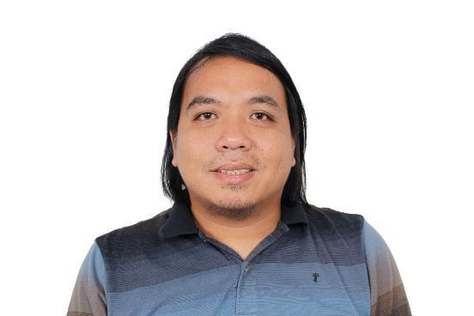
DEXTER DEXTER.364951@2freemail.com

Position Desired

Revit Draftsman / BIM Modeller

Objective

To seek for a job that will allow me to maximize and improve my skills and knowledge and to fully contribute to achieve the goals of the company.

Skills

Proficient in :

- MS office applications

- AutoCad

- Revit Architecture & Structural

Educational Background

Tertiary | : | Bataan Peninsula State University (Main Campus)
 |  | Balanga City, Bataan
 |  | Bachelor of Science in Industrial Technology
 |  | Major in Drafting Technology
 |  | 2009 – 2013
Secondary | : | Asia Pacific College of Advanced Studies
 |  | Ibayo, Balanga City
 |  | 2003 – 2007

.

Work Experience

Structural/Architectural Cadd Operator
Whiteport Inc. ( DDTKI )

November 2013 – April 2017

Projects: East Field Center, 100 West Makati, SMDC Shine Residences

- Monitor Shop Drawings preparation (whether in-house or outsourced) according to Submittal Registry and Project Execution Schedule

- Make proposals and RFIs on detected clashes

- Coordinates with A/E of record an approval of Shop Drawings

- Reviews all shop drawings with regards to proper coordination and completeness

- Coordinates with operations constructability of shop drawings

- Coordinates with Procurement/Warehousing Rebar Cutting List

- Site inspection in coordination with Operations ensuring shop drawing are followed

- Collects Redlining for As-Built Preparation

- As-built drawings

- Reports to TSG Supervisor whether Architectural/Civil
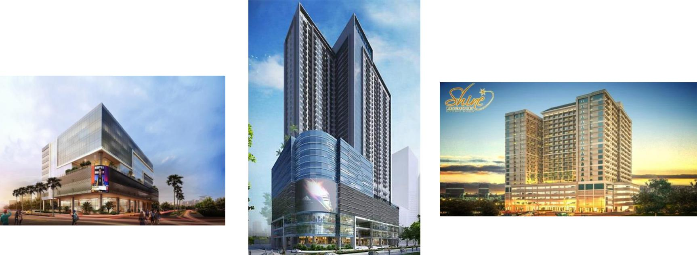
Seminars and Trainings Attended

Revit Architecture
Microcadd Cubao

November 19, 2016 -February 11, 2017

Revit Structural
Microcadd Cubao
February 25 – March 25, 2017

Advanced Autocad

Microcadd SM Manlla
May 7 – May 30, 2013

Industrial Safety Management Training (Basic First Aid Training)
Bataan Peninsula State University, Main Campus

Balanga, Bataan
April 21 - May 11, 2012

Industrial Organization Program Seminar
Bataan Peninsula State University, Main Campus

Balanga, Bataan
April 21 - May 11, 2012

Personal Information

Date of Birth: November 13, 1989

Place of Birth: Omboy, Abucay, Bataan

Status: Single

Sex: Male

Height: 5’7”

Weight: 180 lbs.

Nationality: Filipino

Language: English, Filipino

Religion: Roman Catholic

Type of Visa: Tourist

I hereby declared that all information furnished in this resume is true to the best of my knowledge and belief.

MY SAMPLE WORKS
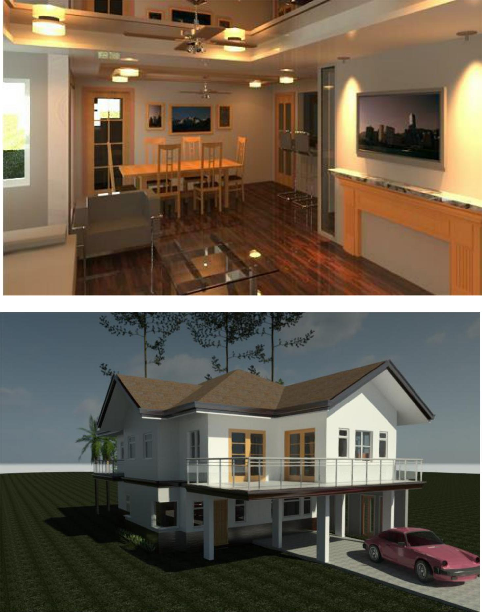

Rebar Detailing
