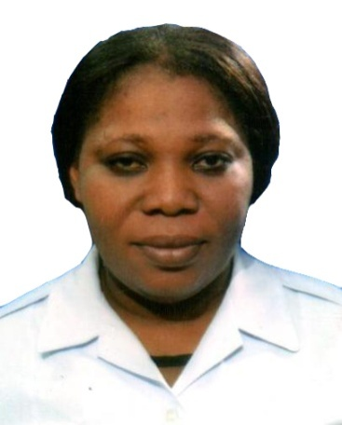
Fatima

PERSONAL DETAILS

Date of birth
May 04th 1978

Gender
Female

Marital Status
Married

Nationality
Nigerian

Visa Status
Employment (Transferable)

Languages Known:
English

Cabin Crew License
License Number: 1169

fatima.364957@2freemail.com

Career Objective
Seeking a challenging suitable position in an organization where I can utilize my experience to carrying out assigned duties effectively and efficiently and add value to the current services offered to customers.
CAREER HISTORY

Presidential Air Fleet, Nigeria May 2005 – Sep 2015
Position: Senior Purser (Cabin Crew)
Duties & Responsibilities:
- Carrying out pre-flight duties, including checking the safety equipment and security checks, ensuring the aircraft is clean and tidy, ensuring that information in the seat pockets is up to date and that all meals, drinks and stock are on board
- Welcoming passengers on board and directing them to their seats
- Informing fliers of the aircraft safety procedures and ensuring that all hand luggage is securely stored away
- Checking all seat belts and galleys are secure prior to take-off
- Making announcements on behalf of the pilot and answering questions during the flight;
- Serving meals and refreshments
- Giving first aid where necessary
- Ensuring passengers disembark safely at the end of a flight and checking that there is no luggage left in the overhead lockers and no stowaways or suspicious items on board

ACADEMIC QUALIFICATION
- West African Examination Council 1996
- First School Leaving Certificate 1989
ADDITIONAL QUALIFICATIONS
- Training And Instructional Techniques Course For Instructors British Airways, East Base London Heathrow, United Kingdom 2015
- Human Performance and Limitations/Crew Resource Management/ Human Factors 2005
- Cabin Crew Ab-Initio 2005
- Class IV Meteorologist,
Nigerian Meteorological Department 2000 - 2002
- Heart saver AED, Abu Dhabi, U.A.E 2009 – 2011
- NSC CPR Course, Quantum HR Consultancy,
Dubai, U.A.E. 2012 - 2014
- Safety and Emergency Procedures Training 2014 – 2015
- CRM Course, Emirates CAE Flight Training 2009
- Dangerous Goods-Internet Based Training,
Emirates CAE Flight 2009
- Catering, National Center for Women Development Abuja 2003

Cabin Crew Courses Attended at Emirates Aviation College, Dubai, U.A.E
Cabin Crew Refresher Course and
Workshop (Recurrent) 2007 - 2015

Courses Attended
- Real Fire Fighting Drills
- Joint Aviation Security Training
- Wet Ditching Drills, Life Raft Description and Familiarization
- Equipment Hands-on Training: Fire Extinguisher, Smoke Hood, Life Jacket, Portable Oxygen bottle
- Simulator Practical’s (Fire, Decompression, RTO, RTF, Evacuation Techniques and Sliding)
- Cabin Crew CRM (Human Factors/Threat & Error)
- Dangerous Goods
- Cabin Crew Review – Safe Practices
- Pilot Incapacitation
- Life Raft / Wet Ditching Drills
- Cabin Simulator Practical Training
- Real Fire Fighting Training
- Dangerous Goods / CRM
- Joint Aviation Security

Computer Skills
- Knowledge of Excellent MS Office Applications (Word, Excel, Power Point, Outlook)

Skills
- Able to work as part of a team or independently with little or no supervision
- Flexible and can be able to work in a multicultural environment
- Superb interpersonal skills and exceptional ability towards greater customer satisfaction
- Excellent communication skills
- Computer literacy
- Ability to work under pressure

Strengths
- Self motivated and ability to communicate with other staff and motivate them
- Problem solving and decision making
- Good Analytical skill and a Quick Learner
- Focused on minute details

References
Can be provided upon request
Declaration
I declare that the information provided above is true and correct to the best of my knowledge.

Fatima

