CURRICULUM VITAE

Shadab
Shadab.364973@2freemail.com 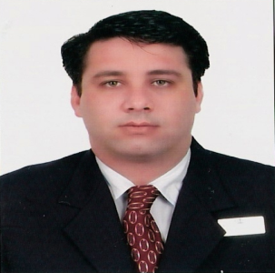

OBJECTIVE: To work for an professional organization in Hospitality Industry which offers challenge with opportunities to increase knowledge and responsibilities with suitable level of promotions for maximum satisfaction.

EDUCATION :

B.A Hons. ( 4 years Degree ) in Hospitality Management from Thames Valley University, London.
Program completed at R.M institute of Hotel Management, New Delhi, India.

PROFESSIONAL PROFILE :

B.A Hons. ( 4 years Degree ) in Hospitality Management from Thames Valley University, London.

PROFESSIONAL EXPERIENCE :

- Habeebee Food Group (Arabia Holdings), Dubai, UAE – Presently Working as Group Restaurant Manager from March 2016

- Deemarks Hotel &Resort, Delhi - 4 years as Unit Manager Operations.

- Princess Hotel, Dubai – 3 years as Food & Beverage Manager & Night Manager.

- Montreal Hotel, Dubai – 2 year as Assistant Food & Beverage Manager.

- Krishna continental hotel, Delhi – 3 years as Assistant Food & Beverage Manager.

- Delhis Devils Restaurant , Delhi– 2 years as Maitre de Hotel.

- Industrial Trainee in F&B, London - 1 year in Quality Hotel Westminster, London.

ACHIEVEMENTS :
- Recognised as the best employee of the month by Quality Hotel Westminster, London.
- Awarded certificate for customer satisfaction by Quality Hotel Westminster, London.
PERSONAL STRENGTHS :
- Organised and focused mind.
- Ability to administratively control, motivate and manage a group or a team.
- Confident and positive attitude enabling me to work under pressure.
- Ability to take immediate action in solving problems.

COMPUTER SKILLS :
MS office, internet and E-mail Applications.

LANGUAGES :
English, Hindi and Urdu.

PERSONAL DETAILS :
Nationality- Indian
Date of Birth – 10.01.1977
Marital status – Married
Visa Status - Employment

