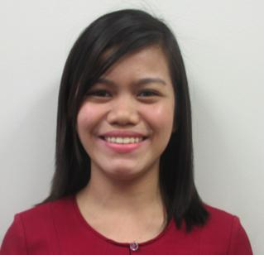
MARIA
MARIA.365023@2freemail.com

OBJECTIVE

To obtain any administrative position through bringing a positive attitude, organized approach, excellent time management and communication skills with great proficiency in MS

Office to enhance company’s productivity and reputation.

EDUCATIONAL BACKGROUND

- Tertiary:
Holy Cross of Davao College, Inc.

BS in Business Administration major in Financial Management

S.Y. 2013-2014

- Secondary:
Sto. Niño High School

S.Y 2009-2010

- Primary:
Binuni Elementary School

S.Y 2005-2006

WORK EXPERIENCE

Portfolio Review and Monitoring Assistant (2014-2017)
One Network Bank, a Rural Bank of BDO

Davao City, Philippines

The largest rural bank in the Philippines with more than 120 branches that provides a wide range of financial products and services including loans, deposits, cash management, remittances and bill payments.

- Ensures profitability of the salary loans portfolio in each institution.

- Evaluates each loan accounts being applied by the branches for permanent exclusion and presents the accounts for executive committee’s approval.

- Timely reviewed and monitored the performance of the Salary Loans Portfolio Performance of all branches.

- Provides assistance to the branches through answering their enquiries in phone calls and emails.

- Research and recommend significant enhancement of the new programs/systems.

- Maintain files, documentation and records thoroughly, timely and accurately, in accordance with company policy and accepted practices.

On-the Job Trainee (2013)

United Coconut Planters Bank

Davao City, Philippines

- Answers telephone and electronic enquiries, forwards phone calls to appropriate person.

- Demonstrated ability to reply and attach files to incoming mails.

- Compiled data and organized the confidential files.

- Summarized, verified and compiled incoming bank checks.

SKILLS

- Highly skilled in maintaining paper and online filing systems for confidential records and messages.

- In-depth knowledge of routing and managing incoming mail and email.

- Track record of operating photocopiers, fax machines, phone systems and other office tools.

- Good research and analytical skills

- Self-starter with the ability to multi-task, work under pressure and manage time effectively.

- Proven ability to use computers for word processing, excel, powerpoint and outlook.

- Dedicated and careful in high level of correctness and strong attention.

AFFILIATIONS

- Junior Finance Executive Member (2011-2013)
- Civil Service Non-Professional passer (2013).
- Completed Loans Specialist’s Training (2014).
- Completed AMLA Training (2014).

- Passed the AML Refresher Course and Customer Acquisition Policy and AML case analysis (2015)

