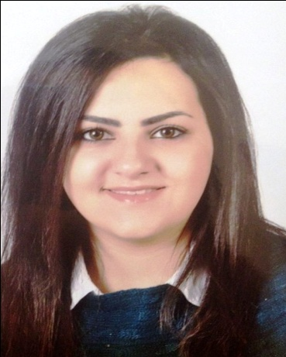
Noor.365034@2freemail.com
Personal Information:
Name: Noor

Objective:

Skilled professional General Dentist with DHA eligibility and over 3 years of experience, looking for opportunities in established practice, to associate into partnership. Open to all options, with motivation and ambition to utilize knowledge and skills in all areas of general practice. Willing to learn and excel under good mentor as well as incorporate my own ideas into growing a successful practice.

Background:

Fall 2008-Spring 2013 Al-Quds University School of Dentistry
Jerusalem, Palestine
- Bachelor degree of Dental Surgery
- Average: 76.8 (a rating Good)

Fall 2007-winter 2008 Red Deer College. Red Deer, Alberta,
Canada
- BA science Nutrition food science
- Good standing

2000-2007 Middle East International School.
Riyadh, KSA
- Elementary and high school
- High school average: 93.0 (GPA 3.67)

Career History:

Experience:
Worked as a general dentist (September 2014- September 2016) at Dr.Mahmoud Abo Mwis Clinic (Palestine, Jenin)

Responsibilities:
- - Diagnosed dental conditions in adult and pediatric clients
- - Extracted teeth as required
- - Performed oral prophylaxis or teeth cleaning
- - Done cavity filling and placed sealants as warranted
- - Whitened teeth with medications and laser procedures
- - Installed Orthodontic braces in patients with bite problems
- - Provided anesthesia prior to procedures
- - Prescribed pain medications and antibiotics to patients
- - Conducted follow-up sessions with patients
- - Instructed patients on proper dental care and regular check-up

Internship:
Completed 1 year of internship in Palestine at the Ministry of health and private dental clinics (September 2013- September 2014)

Responsibilities:
-Conducted school Dental Awareness
-Conducted Health Education
-Involved various types of cases which included:
- Root canal treatment and Digital Radiography
- Dental cleanings
- Composites, Amalgam Restorative fillings and Complete Dentures.
- Fixed Partial dentures
- Oral Prophylaxis
- extraction (simple and surgical)

Specialized skills:
-Excellent diagnostic skills using clinical knowledge and x-rays
-Excellent theoretical knowledge
-Excellent verbal and written communication skills
-Good knowledge of clinical practices and protocols
-Ability to handle different types of patients
-Flexible and adaptable
-Extremely motivated towards career

Achievements and attendance:
- Attended the first Jordanian international oral and maxillofacial surgery conference (march 28th -30th )
CME (12) Hours
- Certificate of achievement in A+ Core Hardware, Microsoft FrontPage XP & Hypertext Markup Language
- Attended the second international congress for oral implantology in Palestine (December 11-14,2013)
CE (18) Credit Hours
- Attended a training course in rotary system for tooth that need endodontic teeth
- Attended a training course in implant and surgical flap procedure

Professional Details:
- Professional Experience :3 year
- Languages known :
English (excellent)
Arabic (excellent)
French (good)

