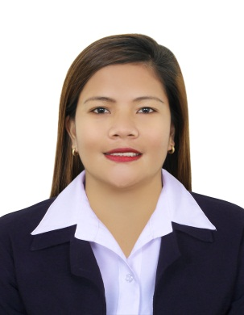
MAY
May.365107@2freemail.com

EDUCATIONAL BACKGROUND:
COLLEGE : University of Northern Philippines Vigan city ilocossur
Course : Bachelor of Science
Major : Biology

WORK EXPERIENCE:

2014-2017: RECEPTIONIST CUM OFFICE ASSITANT AETIUS MEDIA (DMCC)
- Welcomes visitors by greeting them, in person or on the telephones, answering or referring inquiries.
- Directs visitors by maintaining employee and department directories, giving instructions.
- Maintain security by following procedures and controlling access via the reception desk.
- Update appointment calendars and schedule appointment/meetings.
- Perform other clerical duties such as filling, photocopying, faxing etc..
- Maintains safe and clean reception area by complying with procedures, rules, and regulations.
- Maintains supplies by checking stock to determine inventory levels; anticipating requirements; placing an expediting orders; verifying receipts; stocking items, delivering supplies to work actions.

2012-2014: MAIDS.AE CLEANING COMPANY
- Responsible of cleaning houses, apartments, vacuums, wash dishes, sweep floors, launders clothes, clean and scrub counters and dust surfaces.
- Keep the houses and apartments clean and well organized
- Making bed and taking out laundries.
- Wash dishes, clean bathrooms and kitchens, wash windows and mirrors.
- Ironing clothes, taking care of pets like dogs and cats.

2010-2012: PROMO DICER (JTC CORPORATION)
- Responsible to sell products to customers.
- Ensure that customer needs are satisfied and exceeded.
- Assist the needs of customers while at the same time promoting products that you’ve been assigned.

2007-2010 SALES STAFF (TWO BROTHERS GROCERY)
- Welcomes customers into the store, asses their requirements and answer their queries.
- Arrange and displays products to attract customers.
- Put price tags on products and adjust the prices of promotional or sale item.
- Keeping the merchandising are clean.

2006-2007 SERVICE CREWS (AZIZ FOOD RESTAURANT)
- Responsible for providing courteous and efficient food and beverages services to the guest.
- To present menu, take out order, suggest and recommend appropriately.
- To attend and respond the guest needs promptly and professionally.
- To present bills to diners, collect payments and give to cashiers, return change and credit cards to diners.

Skills:
- Computer Literate
- Ability to carefully provide good customers service.
- Outstanding time management skills.
- Capability to perform full time job.
- Capability to maintain helpful environment in work area
- Dedicated and hardworking individual.

PERSONAL DATA:

Date of Birth: May 12, 1986
Civil Status: Single
Citizenship: Filipino
Visa status: UAE Employment visa
Language: English, Tagalog

Reference: Available upon request.

