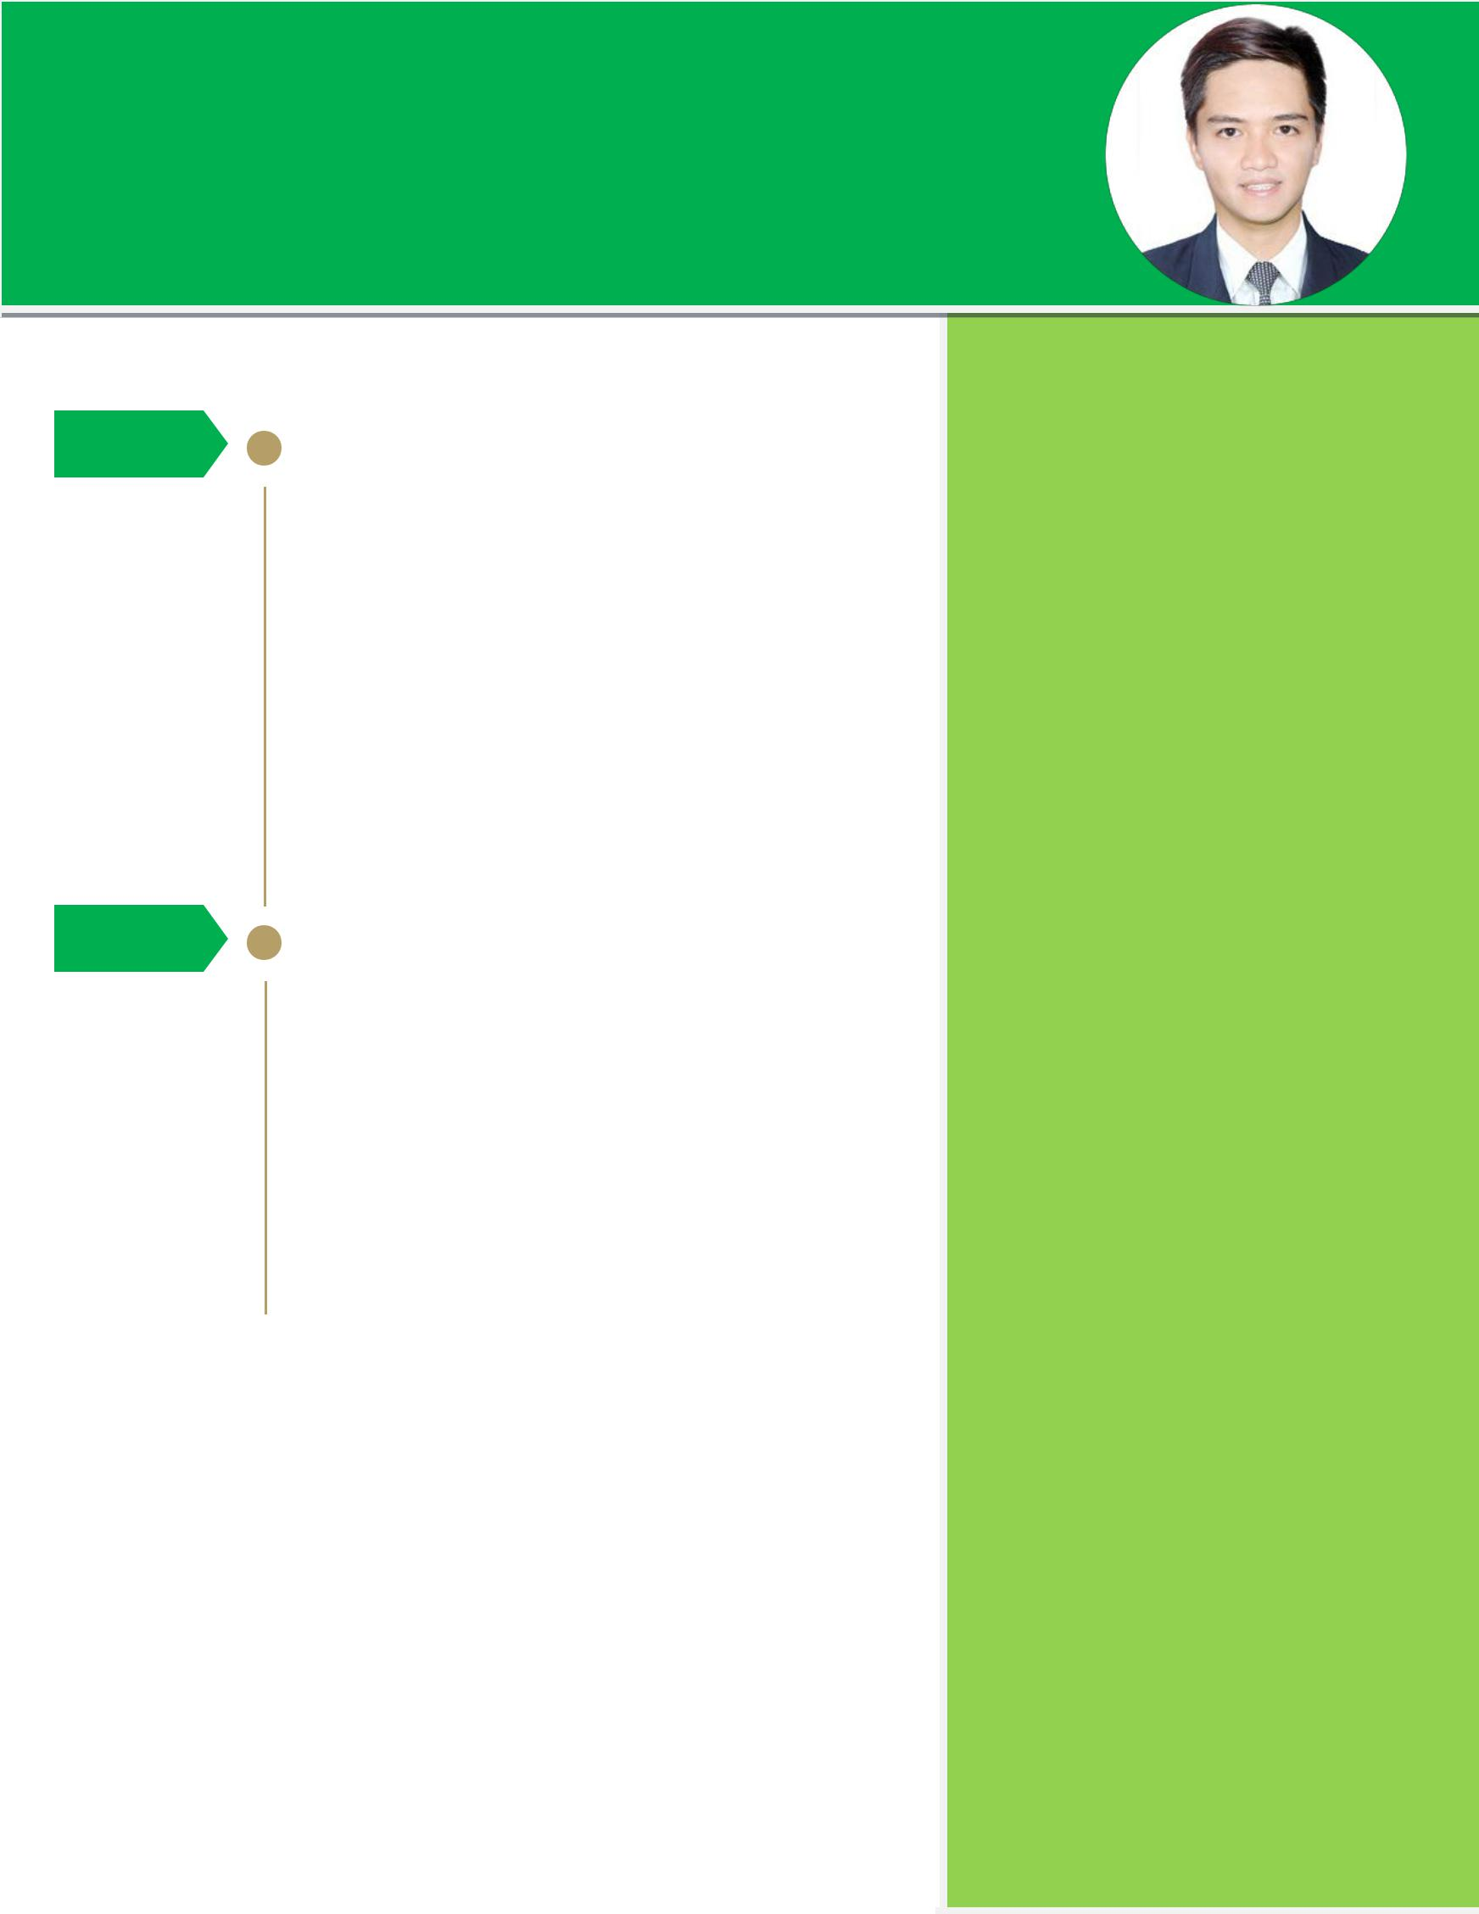
KIM KIM.365122@2freemail.com

Young nurse professional with years of experience of continuous quality work in the field of Health care, both hospital and community base setup.

Experience

2014 – 2017 | NURSE II- Department of Health, Region Office III
 | Municipal Health Office Guiguinto, Bulacan

- Implementation of various health programs of the Local Government Unit in accordance with the program goals and objectives of the Department of Health.

- Assessment and registration of patient’s with Tuberculosis and supervises in DOTS and their consultation and monitoring.

- Member of the Municipal Epidemiological Surveillance Team which conduct communicable diseases such as MERS-COV, meningococcemia, rabies, leprosy, dengue, SARS, Birds flu and other re-emerging diseases.

- Supervises on immunization to all infants (with vaccine available in the facility), pregnant women, children and adult as per physician request.

- Conduct health education and training to health personnel.

- Render appropriate health services as needed by the community.

- Preparation and analysis of reports on clinic and community activities.

- Conduct HIV Counseling for walk-in and volunteer clients.

2011 - 2014 | STAFF NURSE- EMERGENCY DEPARTMENT
 | United Balagtas Doctors Hospital Inc.
- Performs physical assessment

- Detects abnormalities from the assessment and result of diagnostics examinations and reports

- Establishes nursing diagnosis

- Prioritizes needs/ problems of patients

- Carries out plan of care

- Administers prescribe medications and treatments

- Records assessment, intervention and evaluation of nursing care

- Evaluates effects of nursing

- Revises plan of care as necessary

Training and Seminars

- Training on HIV Counseling and Testing

- Primary Care Training for Adult Client with HIV Infection

- HIV and AIDS Core Team Training

- Training on Treatment Adherence Counseling

- Training on Peer Education and Stigma Reduction for HIV and STIs

- Basic Life Support with AED

- Safety Practices in IV Therapy for Health Care Professional

- Infusion Therapy Devices

- Neonatal Intravenous Therapy

Examination

Health Authority Abu Dhabi (HAAD)
Registered Nurse

February 15, 2017
Status: PASSED

Skills

P E R S O N AL
- Strong Work Ethics & Values

- Multitasking Skills

- Confident in Communication

- Critical Thinking in Problem Solving

ADMINISTR ATIVE & GR APHICS
- Computer Literate

- MS Word

- PowerPoint

- Excel

- MS Publisher

- Outlook

Education

Bachelor of Science in Nursing

2007- 2011

Our Lady of Fatima University Marulas, Valenzuela City Academic Scholar

PERSONAL INFORMATION

Birth date: January 3, 1991

Birth place: Guiguinto, Bulacan, PH

Civil status: Single Height: 5’6” Weight: 130lbs Nationality: Filipino
Religion: Roman Catholic

Visa Type: Visit Visa

