
Curriculum Vitae (Tayma'a)

Tayma.365149@2freemail.com

PERSONAL INFORMATION
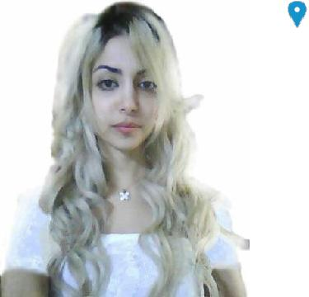

Sex Female | | Nationality Syrian.

WORK EXPERIENCE

Dates( 2016 )

( 2016)

( 2015)

( 2013- 2014)

Doctor at my own private clinic.

Trainee at the Surgical Department at The National Hospital for 3 months.

Assistant teacher of the Operative Department of the Faculty of Dentistry for about a year.

Practical experience as an assistant dentist at Dr. Samer Dawod private clinic for about a year.

( 2013 -2014)

EDUCATION AND TRAINING

Clinical and practical experience during the Fourth and Fifth Years of collage for about two years.

Replace with dates ( 2015) Got a certificate after six months of scientific training course on oral implantalogy at Tishreen University, Faculty of Dentistry in cooperation with AIIO / Academie France - Paris.

(2014)

( 2013 / 2014)

( 2009)

PERSONAL SKILLS Mother tongue(s)

Got a training certificate of 16 working hours for applying dermal fillers.

Bachelor in Dentistry.

General Secondary Certificate.

Arabic.

© European Union, 2002-2013 | http://europass.cedefop.europa.eu Page 1 / 2

Other language(s)

English

Communication skills

Organisational / managerial skills

Computer skills

Curriculum Vitae |  | Replace with First name(Taima'a) Surname(Taha)
UNDERSTANDING |  | SPEAKING |  | WRITING
Listening | Reading | Spoken interaction | Spoken production
5.5 | 5 | 8 | 8 | 7
 |  | Ilets. 6.5

- Good communication skills gained through my experience as an assistant teacher as well as out of work at a private clinic as an assistant doctor.

- leadership (currently responsible of two classes of 35 - 70 students.

- Good command of Microsoft Office™ tools, have an ICDL certificate.

Other skills | ▪ Reading / Writing poetry / sports.
Driving licence | I have a driving licence
 | B
ADDITIONAL INFORMATION
Projects | A graduation project about Systemic Complications of local Anesthesia.
Conferences | I have participated in the eleventh conference of the Faculty of Dentistry at 15 - 16 April
 | 2014 and also attended the tenth conference at 12 - 13 May 2013 about Dentistry in
 | General.
Seminars | An Implantalagy seminar during my fifth year in college.

Signature Taymaa

Tishreen University

Faculty of Dentistery

Lattakia/ Syria

© European Union, 2002-2013 | http://europass.cedefop.europa.eu Page 2 / 2

