PERSONAL INFORMATION
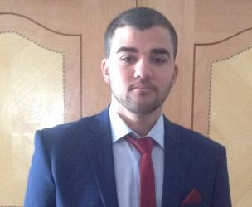

WORK EXPERIENCE 2016– present

Spring 2012

EDUCATION AND TRAINING

Momin
Momin.365157@2freemail.com

Update Technologies

- Creating, configuring, and maintaining Networks.
- Installing and configuring computer hardware, operating systems, monitoring systems, printers and scanners, and their corresponding applications.

Volunteer

Public Relationships Department NNU, Nablus, Palestine

- Acted as coordinator for diverse department activities.

- Organized extra circular activities for university students.

Higher education

2012- 2016 AN-NAJAH NATIONAL UNIVERSITY, Nablus, Palestine Bachelor of Computer Science. Very good honors (GPA: 3.0)

2012 KING TALAL SECONDARY SCHOOL, Nablus, Palestine

Class of 2012. Science stream. GPA: 88.2%.

Training

Summer 2015 “Cisco Certified Network Associate" at Hisham Hijjawi College of Technology, Nablus, Palestine (90 training hours).

Page 1 / 2

PERSONAL SKILLS
Languages | ▪ Native Arabic & good English.
Organisational / managerial | ▪ Strong organisational and prioritisation skills.
skills
Programming Languages and | ▪ C/C++ | ▪ Android.
API’s | ▪ Java | ▪ Basic knowledge of PHP
 | ▪ MySQL
 | ▪ HTML/ CSS
Computer skills | ▪ Profound knowledge of different operating systems (Linux, Windows).
 | ▪ Excellent command of Microsoft Office™ tools.
Other skills | ▪ Enjoy teamwork.
 | ▪ Ability to work under pressure.
 | ▪ Ability to work long hour.
 | ▪ A passion to learn and explore new technologies.
 | ▪ Reading: passionate reader.
 | ▪ Enjoy all sports particularly running.
Driving licence | ▪ Palestinian driving licence and ability to get an international one.
ADDITIONAL INFORMATION
Projects | ▪ Designed and developed a carpooling mobile application.
 | ▪ Public relationships “Database project” which was developed to deal with volunteers,
 | organize their work and schedule their tasks.

Page 2 / 2

