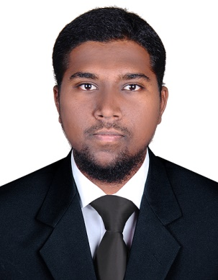
CURRICULUM VITAE

Khalifa
Khalifa.365201@2freemail.com

As a HSE Officer with 4 yrs. and 3 months Experience in Civil Constructions and Facilities Management in Gulf & India.

Career Objective:

To seek a challenging position and to dedicate my service to a reputed organization to expose my talents and skills

ACADEMIC CREDENTIALS:

B.C.A (Bachelor in Computer Application) –The New College, Chennai, India

SAFETY QUALIFICATION:

IOSH (UK): Managing Safely – NIST, Chennai, India

Level-2(UK): Principles of Risk Assessments- NIST, Chennai, India

Level-2 (UK): Fire & Safety – NIST, Chennai, India

WORK EXPERIENCE

SAFETY SUPERVISOR at Kwaseb Est. (Saudi Arabia)

Projects: Saudi Post, Ministry of Hajj and Saudi Airlines (Facilities Management)

Place: Makkah, Saudi Arabia

From: 26/01/2014 to 31/01/2017

Duties:

Inspect facilities periodically to determine problems and necessary maintenance.

Monitor inventory of materials and equipment.

Supervises and assigns the work of maintenance employees.
Plan and direct housekeeping team members to carry out their duties.
Supervise housekeeping members and conduct detail inspection of all rooms and Service areas.
Supervise room cleaning and replenishing duties.

Issue supplies to housekeeping staff at the beginning of each shift.

Ensure appropriate maintenance of all housekeeping equipment and tools.
Maintain inventory of tools and supplies used in housekeeping activities.

SAFETY SUPERVISOR at Delta Constructions System limited

Projects: Chennai Metro Rail Project (Mining, Excavations)

Place: Chennai, India

From: 15/032012 to 03/10/2013

Duties:

Inspects workplaces and directs employees to ensure that people and property are kept safe at all the times.

Oversee the work performed by the laborers that they are following legal and company safety guidelines.

Regularly inspects equipment, tools and building materials to ensure quality and safety.

To check the machinery is properly maintained and the workers wear appropriate safety gear such as helmets, goggles, hand glows, safety shoes at all the times.

Co-ordinate and monitor the "Permit to Work" system. · control lifting equipment and movements of vehicle on the site per international safety standard.

Accident investigation / Reporting, weekly safety report to the management.

Take advice and instruction from the HSE manager.

Make every effort to prepare safe working environment.

To achieve zero accident reports.

STRENGTHS:

- Ability to lead and organize things.

- Ability to work co-operatively with others.

- Efficient time management and organizational skill.

- Ability to communicate in four languages Arabic, Hindi, English and Tamil.

COMPUTER SKILLS:

Software Tool : MS Office, Excel, Power Point
Operating System : Windows (7, 8, 10)
Web Language : HTML

PERSONEL DETAILS:

FATHER NAME : K.S.MOHAMED YUSUF ALI

D.O.B : 03.05.1991

GENDER : MALE

MARITAL STATUS : SINGLE

NATIONALITY : INDIAN

RELIGION : MUSLIM

LANGUAGES KNOWN : ARABIC, HINDI, ENGLISH, AND TAMIL

VISA VALID TILL UAE : 10/06/2017 (VISIT VISA)

DECLARATION:

I do hereby declare that the particulars of information and facts stated herein above are true, correct and complete to the best of my knowledge and belief.

