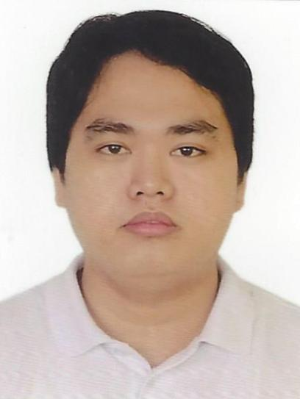
CUPIDO
Cupido.365219@2freemail.com

OBJECTIVE

To secure a position in the organization that offers challenge and opportunity for my career development and at the same time serve the organization to the best of my capabilities. I would like to gain new skills while utilizing my current area of expertise of procurement and employee satisfaction services within a positive environment.

SKILLS AND INTEREST

- Computer troubleshooting, sales and presentation skills, persuasive skills, typing skills 35 wpm, internet navigation skills and customer-service oriented.
- Multi-tasking, team-player and leadership skills.

PERSONAL QUALITIES

- Goal-directed, results oriented, skilled communicator, persuasive and adaptable.
- Self motivated with high energy, initiative and focused.
- Keen insight into needs and views of others.
- Possess special sensitivity to meeting diverse needs in varied situations.
- Dedicated individual, reputation for consistently going beyond what is required.

WORK EXPERIENCE

- Customer Service Representative (Call Center Agent)
ALORICA PHILIPPINES INC.
Chino Roces Ave., Makati City Philippines.
September 2015 – December 2016

Duties and Responsibilities
- Deliver excellent customer service at all times.
- Answering telephone calls and verifying information.
- Deal with all inquiries in a professional and courteous manner.
- Informs clients by explaining procedures and providing information.
- Always adhere to all company policies and procedures.

- Sales Representative
SM Appliance Center
SM Fairview Quirino Highway corner Regalado, Fairview, Quezon City, Philippines.
August 2014 - August 2015

Duties and Responsibilities
- Serves customers by selling products; meeting customer needs.
- Monitors competition by gathering current marketplace information on pricing, products, new products, delivery schedules, merchandising techniques, etc.
- Contributes to team effort by accomplishing related results as needed.
- Recommends changes in products, service, and policy by evaluating results and competitive developments.
- Resolves customer complaints by investigating problems; developing solutions; preparing reports; making recommendations to management.

SEMINAR ATTENDED

- 5-Day Intensive Course for Call Center Agents
BPO TRAINING ACADEMY INC.
Makati City, Philippines
March 28 – April 1, 2016

EDUCATION

College : Computer Technology
Asian Institute of Computer Studies
Novaliches, Quezon City Philippines
2013 –2014

Secondary : Deparo High School
Cabatuhan Road, Caloocan City, Philippines
2005 – 2009

PERSONAL DETAILS

Nationality : Filipino
Date of Birth : July 30, 1990
Place of Birth : Bislig City, Surigao Del Sur, Philippines
Civil Status : Single
Religion : Roman Catholic
Languages : English, Filipino

REFERENCE

Available upon request.

I hereby certify that the above given information is true and correct to the best of my knowledge and belief.
CUPIDO Applicant

