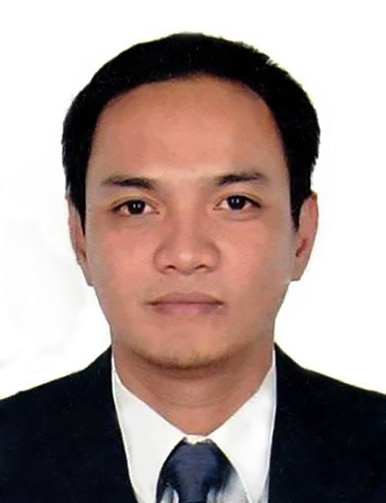
ALDRIN
Aldrin.365226@2freemail.com

OBJECTIVES

I am seeking a competitive and challenging environment where I can serve your organization and establish an enjoyable career for myself.
PERSONAL INFORMATION

Date of Birth: February 07, 1982
Age: 35
Gender: Male
Nationality: Filipino
Religion: Roman Catholic
Marital Status: Married
Language Spoken: English, Tagalog

WORKING EXPERIENCE

Diamond Emission Testing Center
Ulingao, San Rafael Bulacan, Philippines
May 2014 - January 2017
Encoder

Duties and Responsibilities

- Printing various documents needed for the remittance at the end of the day.
- Ordering and maintaining stationery and equipment.
- Organizing and storing paperwork, documents and computer-based information.
- Checking the details of the vehicles and encoding.
- Stenciling the motor and chassis number of the vehicle.

Oscar Cinema / Al Wahda Cinema
Al Wahda Mall, Abu Dhabi, United Arab of Emirates
April 2013 – March 2014
Projectionist / Ticket Controller / Concessionaire Attendant

Duties and Responsibilities

- receiving and checking film reels
- loading the films onto the projector in the right order
- making sure the film runs smoothly through the projector
- checking that sound is operating properly
- joining (‘splicing’) lengths of film together if they break
- storing the films safely
- sending on the reels to other cinemas
- looking after the projection equipment and organising services
- being responsible for heating, lighting, ventilation and alarm systems in the cinema

SM City Baliuag(Department Store)
Pagala, Baliuag, Bulacan
October 2010 – December 2012
Salesman

Duties and Responsibilities

● Present, promote and sell products and services
● Expedite the resolution of customer problems and complaints to maximize satisfaction.
● Establish, develop and maintain customer relationship.
● Analyze the territory / market’s potential, track sales and status reports.

8WAVES WATERPARK AND HOTEL
DRT Hi-way, Ulingao, San Rafael, Bulacan
March 2004 – June 2010
Cottage Attendant / Park Operation Assistant Supervisor

Duties and Responsibilities

● Interviews and selects candidates for employment
● supervises and trains staff
● recommends and takes action on personnel matters
● evaluates subordinate staff

8WAVES WATERPARK AND HOTEL (FOODCOURT)
DRT Hi-way, Ulingao, San Rafael, Bulacan
October 2002 –February 2004
Waiter / Concessionaire Attendant

Duties and Responsibilities

● Greet customers and present Menu.
● Take and serve food/ drinks orders and upsell any additional products.
● Arrange table settings and maintain tables clean and tidy.
● Deliver checks and collect payments.

EDUCATIONAL BACKGROUND

Tertiary

Bachelor of Science Major in Bussiness Administration
Baliuag University, Philippine
Graduated: May 2002

Secondary

Saint Jean Baptiste Academy
Baliuag, Bulacan, Philippines
Graduated: April 1998

Primary

Montessori School of Immaculate Conception
Baliuag, Bulacan, Philippines
Graduated: March 1994

