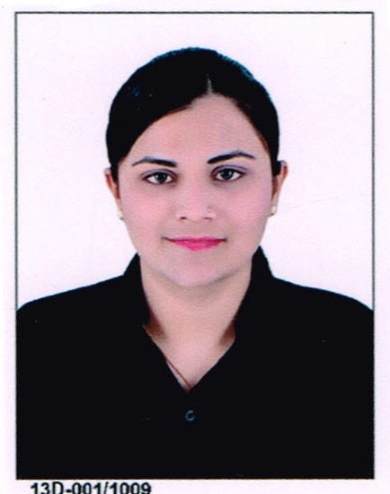  Personal Data:  Date of Birth :  23rd AUGUST,1992  Gender : Female  Nationality : Indian  Marital Status : Married  Languages Known:  Hindi, English,Gujarati.  Interests:  Interested in Meeting and Interacting with People, Love to Travel New Places And Learn Their Culture, Social Work, Cooking. | RUKHSAR  RUKHSAR.365237@2freemail.com  Objective  To obtain a challenging position that will provide me dynamic career growth, where I can utilize my skills to the best of my ability and improve my knowledge /skills face responsibility and charges of the chosen field and also at the same time learn new and use emerging technology to fulfill mature requirements and “My every day becomes a learning day”.  ACADEMIC QUALIFICATIONS  DEGREE BOARD/ UNIVERSITY YEAR PERCENTAGE  Accounting with taxation In Tally.ERP9 PLUS Institute , Navsari 2014 Grade – A  Bachelors of Commerce The Maharaja Sayajirao University of Baroda. April 2013 First Class  H.S.C Zenith High School , Baroda March 2011 74.86%  S.S.C Zenith High School , Baroda March 2008 78.46%  WORKING EXPERIENCE  Company Post Time Period Job Role  Co-Operative Bank, Mughalwada, BARODA Bank Teller 1Year Check cashing / Depositing / Transfers / Wire transfers / Recording transactions.  AL Shirawi Electrical & Mechanical Engineering CO. Dubai,U.A.E Junior HR executive July 2016-October 2016 Labour Accommodation /Staff Welfare /Payment Activity /Petty Cash handling  TECHNICAL SKILLS  - MS-OFFICE  - Accounting with Taxation in Tally.ERP9  - Basics of Windows.  - Master in EXCEL  intrapersonal skills  - Sincerity and perseverance are integral part of my character, coupled with a sound Intellect and Logic.  - Determined, reliable, hardworking and trustworthy individual.  - Ready to undergo any kind of training and transformation to enhance professional skill.  - Having great Team work skills as well individual, Better Communication Skills, works well in all levels of management.  - Can speak fluent English.  - The ability to stay calm and balanced in stressful situations.  - Easily adopt new technology and very friendly and comfortable with  Declaration  I hereby declare that the above written particulars are the best of my knowledge and belief. I Sincerely hope that my application will receive your kind attention and I am most anxious that an opportunity for an interview is given to me at your earliest convenience.

