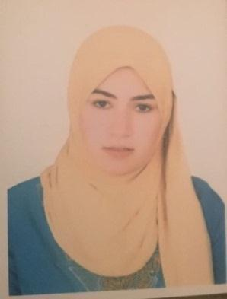

Shaimaa
Shaimaa.365244@2freemail.com

Objective:

Seeking a challenging career to fully utilize my skills in a professional, and international organization, thus enhancing my career chances, and eventually achieving my objectives.

Personal Data :

Date of Birth: 05/09/1995

Marital status: Married

Nationality: Egyptian

Education :

technical institute nursing
graduated with very good degree

Work Experience:

Worked at EL FOUAD INTERNATIONAL SCHOOL clinic since 2015 / 2016

Worked at hospital of zagazig university since 2016/2017

Computer skills :

Microsoft Office Word, MS PowerPoint, MS Excel, MS Outlook, Photoshop, and Internet browsing.

Ability to type at a high speed. Full mastery of all aspects of managing software.
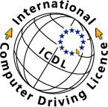

Working skills :

Excellent in multi-tasking

time-management skills

the ability working under pressure

computer and internet skills

team leading

Educational skills :

Excellent research conductor, Good analytical skills, Excellent presentation skills .

Other Skills :

Languages : Arabic : Native speaker

English : Advanced

Declaration

I hereby declare that, to the best of my knowledge and beliefs, that the Information furnished above is true and correct.
I’m hoping that you give me a chance to be a part of your team and I assure you may at most honest integrity, high sincerity and exceptional

N.B.

All the certificates & reference are furnished upon your kind request.
Hope my application will be given your consideration and waiting your soon reply.

