Faizanuddin

Faizanuddin.365247@2freemail.com

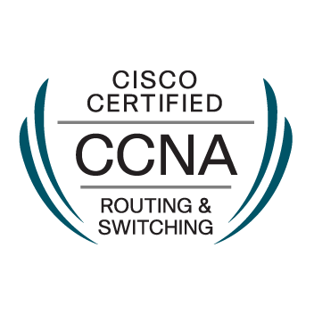

COMPUTER SCIENCE ENGINEER

- CCNA R&S (Certified)
- CCNA Voice
- CCNP R&S

Educational Credentials

- CISCO Certification details: Certification Id: CSCO13162465

- Bachelor’s Degree in Computer Science Engineering - Jawaharlal Nehru Technological University, Hyderabad, India [2015]

WORK PROFILE

Designation: Network Engineer
Focus Softnet Pvt.Ltd, Hyderabad India, (Oct 2015 – Feb 2017)

Responsibilities:
- Basic technical support at the network level: WAN and LAN connectivity, routers, firewalls, and security.
- Install and support LANs, WANs, network segments, Internet, and intranet systems.
- Install and maintain network hardware and software.
- Ensure network connectivity throughout a company’s LAN/WAN infrastructure is on par with technical considerations.
- Design and deploy networks, perform network address assignment.
- Assign routing protocols and routing table configuration.
- Assign configuration of authentication and authorization of directory services.
- Troubleshooting Network Related Issues.

Technical Skills Set:

- Networking candidate possessing good knowledge about computers and networking practices; seeking a position as Networking Engineer in an established organization.
- Good knowledge on desktops.
- Sound knowledge of various operating systems and security software for desktops and mail servers.
- Proficient in best networking practices

Skill Matrix

Software Tools | C, C++, MS – office, Windows XP/ 2000/Windows 7/windows 8/windows 10. Internet Explorer, Search Engines.

Personal Profile

Date of Birth : 21ST Feb 1994
Nationality : Indian
Marital Status : Single
Languages : English, Urdu, Hindi
Visa Status : Visit Visa valid till 15th July 2017

