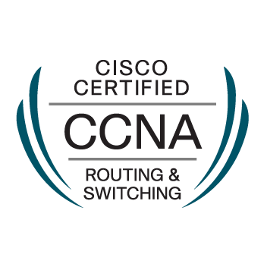
KUMARESAN

Kunaresan.365252@2freemail.com

COMPUTER SCIENCE AND ENGINEERING

OBJECTIVE:

I would like to work in a challenging organization where my skills and knowledge are utilize for organization growth and success.I believe my technical and communication skills will help me for facing the career.
CERTIFICATION:

- CCNA-V3 certification valid until april-2020.
EDUCATIONAL QUALIFICATIONS:

- B.E Computer Science and Engineering | 2008-2012 | 68.1%
Shanmuganathan Engineering College, Tamilnadu,India.
- HSE, Sacred Heart Hr Sec School, | 2006-2008 | 77%
Tamilnadu,India.
- SSLC, Govt.High School, | 2006 | 89.8%
Tamilnadu,India.
TECHNICAL SKILLS SET:

- Operating System : Windows 7,8,10
- Server : Windows 2008R2,2012R2
- Packages : Ms_office2016

RELEVANT EXPERIENCE:

1. Professional Security Systems-Abudhabi

IT Support Engineer January2015-till date

NATURE OF JOB:
- Responsible for CCTV, Network design and troubleshoot.
- Setup and configure routers, switches, desktop computers, laptops, network printers and DVR.
- Design and implement network structure by using routing topologies such as static and dynamic.
- Server installation, maintenance and backup checking.
- Create new users and deal with password issue for both network and CCTV.
- Setup and configure WAN, LAN connections.
- Set users restrictions by using Access control lists.
- Handling virus issues and Antivirus Software issues.
- Outlook 2016 installation and configuration.
- Monitoring and operating (playback, time search and backup) CCTV‘s DVR.
- Installation of all kinds of application software and drivers.

2. YCH Logistics India Pvt Ltd-Chennai

Desktop support engineer Oct2013-Nov2014
NATURE OF JOB:

- PC Assembling & all type of Drivers installation
- Installation of all kinds of application software
- Providing desktop computer software and hardware support, Configuration, repairs, maintenance and installation
- Troubleshooting browser installation, email software, TCP/IP setup
- Installation & Maintenance of LAN, Network Printer & Device Drivers.
- Handling virus issues and Antivirus Software issues for Desktops / Laptops.
- Installation and Software support in respect of Operating System WIN XP, WIN 7 and Antivirus.
- Outlook installation and configuration.

- YCH Logistics India Pvt Ltd-Chennai

Process Executive Sep2012-Oct2013

NATURE OF JOB:

- Responsible for all inbound documents& inventory activities
- Maintaining inbound tracker like Manifest report , inbound shift report and damage report.
- Audit daily, weekly count and conduct monthly PI count.
- Responsibilities inbound and outbound operations and storage in warehouse.
- Responsibilities in recorded all the receipts, and transferring materials.
- Count for over 320 parts.
PERSONAL DETAILS:

Name : Kumaresan.R
Father’s Name : Ramamoorthy.M
Date of Birth : 23th June 1991.

Gender : Male
Marital Status : Single
Passport validity : 17th September 2023

Visa status : Employment visa

Date: | [KUMARESAN.R]
Place:

