CURRICULUM VITAE
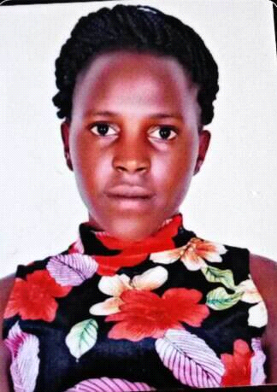

Najjeero.365283@2freemail.com

NAME: NAJJEERO
AGE : 22
STATUS: SINGLE
COUNTRY : UGANDA
NATIONALITY: UGANDAN
- EDUCATION BACK GROUND
PRIMARY SCHOOL: ST JOSEPH KALANGALA PRIMARY SCHOOL
PERIOD: 2006 TO 2012
QUALIFICATION: PRIMARY LEAVING EXAMINATIONS CERTIFICATE (P.L.E)
HIGH SCHOOL: BUKULULA SENIOUR SECONDARY SCHOOL
PERIOD: 2013 TO 2016
QUALIFICATION: UGANDA CERTIFICATE OF EDUCATION (U.C.E)
CERTIFICATE IN FOOD AND NUTRITION
- WORK EXPERIENCE
AFRICAN LOUNGE AND RESULRANT
PERIOD: 2011 TO 2013
SKILLS: WAITER AND BED LAYING (HOUSEKEEPING WORK)
EXPERIENCE : 1 YEAR
KIDDAWALIME BAKERIES
PERIOD: JUNE UP TO NOW
SKILLS: CAKE BAKER
EXPERIENCE: 9MONTHS
OTHER SKILS
- GENERAL ASSISTANT WHERE POSSIBLE
NOTE: am a very good first leaner and good spokes woman
LAUGAGE
ENGLISH (EXCELLENT)
HOBBIES
- WATCHING MOVIE

REFERENCE;

