CURRICULUM VITAE

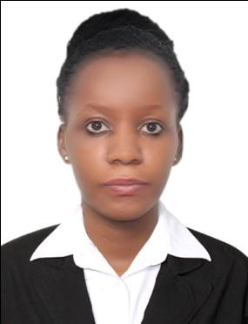
Name : JOWERIA JOWERIA.365298@2freemail.com

OBJECTIVE
Seeking a position in an esteemed and challenging environment where I can strive for simplicity of company’s presentation of products and services by applying my Knowledge, Training, Experience and Expertise to help maintain the high Standards and Goals set by the company.

PROFILE STATEMENT
A dedicated professional with over 5 years combined experience as a customer service professional in retail and hospitality environments now seeking to contribute my experience, skills and expertise to the achieving set company goals.

WORK EXPERIENCE
2015 – DATE: FARNEK TOTAL FACILITIES MANAGEMENT LLC.UAE)
Position held: HOSTESS
DUTIES AND RESPONSIBILITIES:
- Great and seat the guest
- Assign and escort the guest to the table and provide the menu
- Meeting and greeting arriving guests and bidding them farewell as they leave
- Attend to guest inquires and assist them in their needs
- Listening and providing solutions to their issues and concerns

2013- 2014: SHERATON HOTEL (UGANDA)
Position held: HOST/WAITRESS
DUTIES AND RESPONSIBILITIES:
- Giving each guest a personal recognition by addressing them by tittles and seating them upon their arrival
- Manage the front desk by receiving incoming calls, greeting and attending to customers
- Setting the mood for the meal and evening ahead
- Accurately take and honour reservation requests made in person and by telephone
- Have full knowledge of the policies and procedures of the restaurant
2011-2012: SHOPRITE SUPERMARKET (UGANDA)
Position held: CASHIER
DUTIES AND RESPONSIBILITIES:
- Welcoming, greeting and thanking customers after payment.
- Scanning goods and collecting payments.
- Issue receipts, refunds, change and tickets.
- Make sales referral, cross well products.
- Resolve customer complaints

EDUCATION
2012
Makerere University Uganda- Barchelors in business administration
2011
Uganda Advanced Certificate of Education- Gabba Secondary School
2009
Uganda Certificate of Education-Kibibi Secondary School
2005
Primary Leaving Examinations-Gabba model primary School

TECHNICAL SKILLS
- MS Office, Microsoft PowerPoint, Microsoft Word
- Data entry
- Administrative
- Windows

LANGUAGES
- English Fluent
- Arabic Intermediate
- Hindi Basic

CORE COMPETENCIES
- Communication skills
- Customer service orientation
- Information management
- Interpersonal skills
- Listening skills

REFERENCES:
Available on request

