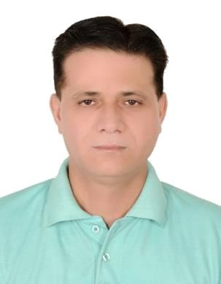

SYED

Syed.365300@2freemail.com

OBJECTIVE

To fully contribute and apply my knowledge, skills, potentials and experiences acquired through years of solid work experience in the field of Hospitality Industry in an organization that will provide opportunities for professional growth.

WORK EXPERIENCE

1. Ayla**** Hotel Al Ain, 29thMay2012 till 11th of Feb 2017.

Night Manager

Specific Duties and Responsibilities:

*Receives guests in a professional and friendly manner, satisfying guest expectations from arrival till departure.

*Maintain effective communication with all related departments during night shift to ensure smooth service delivery.

*Maintains an up to date knowledge of the hotel and local services. Supplies information and responds to guest queries.

*Maintains an awareness of guest profile through the prolific guest profile system.

*Makes controls tours of the hotel ensuring electricity usage is at a minimum and security is at maximum.

*Controls all departments’ keys/master cards.

*Check all necessary reports including rate discrepancy, housekeeping discrepancy, check high balance report.

*To adhere to company and Hotel rules and regulations at all times.

*To comply with any reasonable request made e by management to the best of my ability.

2. Gulf Way****Hotel Karachi, August 02nd2008 till March 03rd 2012

Duty Manager

Specific Duties and Responsibilities:

*Ensure guests are greeted upon arrival, check-in and escorted to room. *Make control tours of the hotel ensuring that cleanliness and security is at maximum. *Handle all guest complaints or problems.

*Responsible for taking immediate action in case an incident (accident, theft, fire, etc) occurs. *Records all important issues and situations on the Duty Manager Report for General Manager.

*To participate in any Training/Developments schemes as recommended by senior management.

3. Sheraton**** Hotel Deira Dubai (Brighton Night Club) Jan 1st 2005-May 31st2008

Assistant Night Club Manager

*Planning, Assigning and Directing work appraising performance, rewarding and providing corrective action.

*Responsible for recruiting, training and arranging the work schedule of the club staff. *Addressing complaints and resolving problems for both employees and guests. *Monitoring the bar staff and providing a high degree of floor presence.

*To supervise the cash flow, handles bank related duties and act as a negotiator in the event of any dispute.

*Meeting with staff to review guest comments to implement revisions and improvements.

4. Highland****Hotel Dubai Aug7th 2001-Dec 28th 2004as Night Supervisor 5.

Owned and operate Outside Catering Business in Karachi Year 1994-2000.

6. Airport***** Hotel Karachi Jan 1st 1990-Sep10th1994 as Senior Front Office Cashier

7. Ramada Renaissance *****Hotel Karachi June 2nd 1987-Dec 13th1989 as Front Office Cashier.

Educational Background

Karachi University: Bachelor of Arts year, 1992 Karachi Board : Intermediate in Science, 1987 Languages

English: Intermediate

Arabic: Working Level

PERSONAL DETAILS

Date of Birth: December 31, 1967

Civil Status: Married

Nationality: Pakistan

Visa Status:

