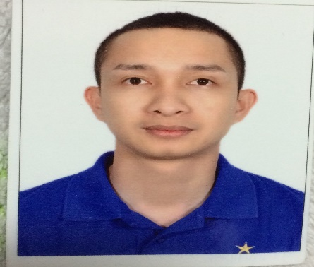
CHARLES CHARLES.365309@2freemail.com

Objectives

I am looking forward to continue my career and share my knowledge and work experiences that will contribute to the success of the Company.

Skills & Abilities

- Team Player
- LANGUAGES: English and Tagalog
- Customer Service Expert (can handles any Guest complain)
- Fast Learner
- A motivated self-starter who takes the initiative, and who can work with minimal supervision.
- Being committed to providing a superior service to any company I work for.
- Fully computer literate.

EDUCATIONAL ATTAINMENT

paTTS COLLEGE OF AERONAUTICS, PHILIPPINES

BACHELOR OF SCIENCE IN TOURISM (UNDER GRADUATE)

work experiences

COMMI CHEF

armani café, al tayer group

galleria mall, abu dhabi U.a.e

july 2013 up to present

Duties and Responsibilities:
- Maintaining high standards of hygiene.
- Preparing the ingredients and measuring the dish ingredients and portion sizes accurately
- Dealing with deliveries and stock rotation
- Maintain the cleanliness of the premises.
- Preparing dish like Pasta, Asian Cuisine and Japanese Cuisine

supervisor

the pizza company, abu dhabi

saleh bin lahej group
JULY 2010 – JULY 2013

Directly supervise and coordinate activities of workers engaged in preparing and serving food. Accomplishes manufacturing staff result by communicating job expectations; planning, monitoring, and appraising job result; coaching, counseling, and disciplining employee; coordinating and enforcing system, policies and procedures.

cook

chillis, dubai

saleh bin lahej group
JULY 2008 - JULY 2010

Duties and Responsibilities:
- Set up and stocking station with necessary supplies.
- Prepare food for services.
- Answer, report and follow executive or sous chef ‘s instruction.
- Clean up station and take care of leftover food.
- Stock inventory appropriately.
- Ensure that food comes out simultaneously, in high quality and in a timely manner.
- Comply with nutrition and sanitation regulations and safety standards.

SUPERVISOR

MANILA PHILIPPINES

OCTOBER 2006 – DECEMBER 2007

WAITER, RIDER, PIZZA MAKER

PICOLO MONDO, MANILA PHILIPPINES

AUGUST 2003 – MARCH 2004

PERSONAL INFORMATION

Date of Birth : September 15, 1982
Age : 32
Nationality : Filipino
Civil Status : Single
Religion : Roman Catholic

