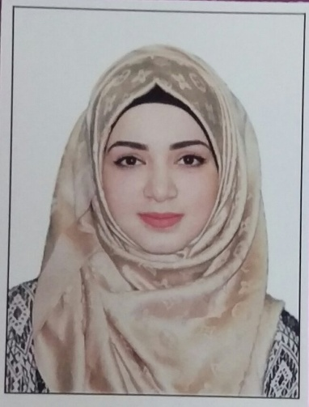

Objectives
Hanin.365353@2freemail.com
Objectives

Seeking New Challenges in a progressive organization, which will effectively utilize my computerized Analytical Skills and design and Commitment to Perform a Quality Work. Looking for advancement and maximum Level of professionalism in systems Analysis.

Education

2014–2017

Al Khawarizmi International College, Abu Dhabi, UAE
Bachelor's Degree in Business Administration (Management)
Graduate project : Customer Satisfaction

Experience

5 March 2017 – 5 April 2017
Worked as Intern at Exceed IT services as HR assistant

Duties:
- Preparing monthly/weekly report such as residence visa expiry report, Annual leave report, new joiner report, offer tracking sheet report.
- Assisting in daily requests for Salary certificate, NOC letters, Salary Transfer, Immigration Letters and Traffic department letters both in Arabic and English.
- Update courses on Exceed system
- Establishes, maintains and update files, databases, records and other documents.
- Follow up to ensure that system is updated with renewed documents.
- Updating manuals and employee records
- Update policy manual

Technical Skills

- Adobe Creative (Photoshop)
- Productivity applications (Word, Excel, Access, PowerPoint).
Management Skills & Knowledge

- Excellent in project and time management skills.
- Good Communication skills and Team work facilities.
- Ability to work independently.
- Good English skills, IELTS certified.
- Excellent Computer Skills.
- High abilities to learn and Understand Problems.
- Able to work under pressure.

Communication Skills
- Arabic: Proficient Reading/Writing/Speaking (mother language)
- English: Good Reading/Writing/Speaking

Personal Abilities
      - Personable and easy to work with
      - Creative and able to think out-of-the-box
      - Strong presentation skills
      - Excellent report-writing skills

References
Are available upon request

