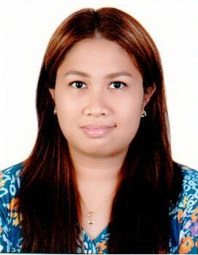
Lynn
Lynn.365356@2freemail.com

Job Objective
Seeking a responsible registered nursing position in a healthcare organization where I can be able to use my knowledge and experience as a nurse to care for patients and/or assist senior nursing staff.
Qualification Highlights
HAAD Licensed, 4 years experience.
Proven record of reliability and responsibility.
Direct care of patients.
Medical terminology and medication administration skills.
Acute and chronic care experience.
BLS/NRP training.
Able to interpret CTGs.
P.C. and Microsoft Office literate.

Professional Experience

Burjeel Hospital, Abu Dhabi
July 2014 – present
Staff Nurse – Labor and Delivery Room
- Assessment and care of ante, intra and postpartum mothers.
- Assist in normal/surgical delivery and primary care of newborns.
- Management of high-risk cases.
- Assist midwives and OBs in care of patients.
- Prepare patients for emergency/elective OB surgical procedures.

Madonna and Child Hospital, Cagayan de Oro City
December 2011-August 2013 December 2011-August 2013
Staff Nurse – OR/DR Complex
● Worked in teams with surgeons, anesthesiologists, others nurses, midwives and ancillary personnel.
● Prepared patients for, and assisted with medical/ surgical examinations and treatments.
● Recorded patients’ medical information and vital signs.
● Prepared operating/ delivery rooms, sterile instruments, equipment and supplies.
● Ensured that stock of supplies is maintained.
● Handed items to surgeons during operations/ deliveries.

Madonna and Child Hospital, Cagayan de Oro City
August 2011-December 2011
Staff Nurse- Medical/Surgical Ward
● Implemented patient care for up to 10 patients per shift.
● Maintained accurate, detailed reports and records.
● Monitored, recorded and reported symptoms and changes in patient’s conditions.
● Interpreted and evaluated diagnostic tests to identify and assess patient’s condition.
● Proper medication administration/ intravenous therapy.
● Observed nurses and visited patients to ensure that proper nursing care is provided.

Educational Background
College:
Xavier University - Ateneo de Cagayan, Cagayan de Oro City, Philippines 2009
B.S. Nursing

High School:
Shekinah Glory Christian Academy, Cagayan de Oro City, Philippines
2004
Graduated, with honors

Primary School:
Shekinah Glory Christian Academy, Cagayan de Oro City, Philippines
2000
Graduated

Skills
- Basic Life Support
- Personal hygiene
- Time Management
- Problem Solving
- Emergency assessment
- Wounds and dressings
- Aseptic technique
- Use of Medical Equipment and Supplies
- Interpersonal and Communication Skills
- Basic Clerical Skills
- Teamwork

References
Available upon request

