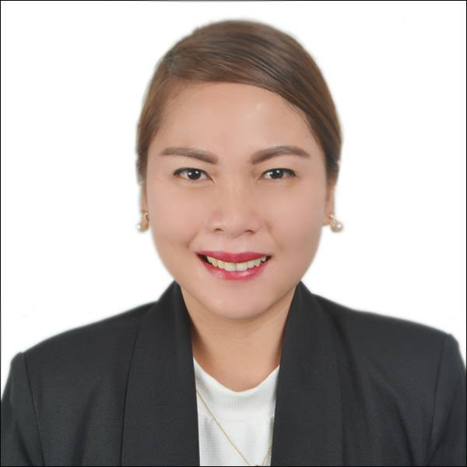
Neldie

Neldie.365370@2freemail.com

Objective
Looking for an Airline Customer Service Agent position that will enable the use of problem-solving, customer service and communication skills.

Profile Statement
Excelled in the role of hospitality. Handling multiple functions including customer queries, administrative tasks and information monitoring. Enjoyed meeting the challenges of a high stress work environment and successfully maintained an efficient and effective customer service.

Working Experience
Receptionist
Beat Swiss Chalet Hotel and Restaurant
March 2015- January 2017
Swiss Chalet Hotel and Restaurant
April 2010- March 2015
JIH Hotel and Restaurant
March 2008- April 2010
- Answering and transferring phone calls
- Handle and redirect customer queries
- Take and distribute messages
- Manage all visitors
- Organize incoming and outgoing mail
- Allocating rooms and hand-outs key to guest
- Making sales report
- Prepare letters and documents
- Utilize MS Office fully in daily tasks and responsibilities
- Set up and maintain accurate data management systems
- Maintain a professional reception area
Education
Holy Angel University, Angeles City, Pampanga, Philippines
Associate in Travel Management 2008
Airline Passenger Services and Handling Course
Feb 3-8, 2017
Airline Services Training Program
February 3-March 2, 2017
International Air Fares and Ticketing Course
February 13-17, 2017
Amadeus Basic Reservation Course
February 20-24, 2017
Service Personality Course
February 27-28, 2017
Omni Airline Services Training School
AVSEC Awareness Seminar
March 1, 2017
Clark International Airport Corporation

Technical Skills
• Amadeus
• MS Outlook
• MS Office

Core Competencies
• Organizational and planning skills
• Communication skills
• Customer service orientation
• Attention to detail
• Information management
• Problem solving
• Reliability
References
Available on request

